# **Abstract**

For the completion of this project, I have used Object Oriented Programming Language PHP, Xampp for database and local server. The aims that this project focuses is to record the information of the clients automatically which saves his/her time, cost and effort.

Customer might be delayed to reach their destination still having left to book a flight ticket so reaching in the airline and then booking flight ticket and go to the airport can waste a lots of time. So through this website customers can book the tickets from wherever they want and whenever they want with the quality service. This is useful for both the airline and the client. The paperwork will be reduce and loss of data would not be feared anymore because the backup will always be supported by this project. Customer can view all the details of flights such as available flights, departure time, arrival time, and their flight reservation details etc.

Admin and User both can create an account and login into the system. Admin will be able to view, add, and update the flight details. Admin can also view the users profile and change the details if there is something negative to the system or if the customer recommend to do so. User can view the flight detail, book the flight they want.

# **Acknowledgement**

Airline Reservation System is an online application which contributes a long range of service to the people of the country. All the clients who visits this website will save their time, effort, and energy.

Thank you to my parents who have always support and help me, and gave me motivation, inspiration, encouragement, and invaluable assistance in finalizing this project within the limited time frame.

I would like to express my special thanks of gratitude to my teacher (Sudeep Lal Bajimaya) and also to the head of the Softwarica College who provided me the golden opportunity to be a part of this amazing project through which I learned to do a lots of research and I also came to know a lots of many new things that have hike up my knowledge so I am really grateful to them.

Table of Contents

**Abstract** 1

**Acknowledgement** 2

**Table of Figure** 5

**Chapter 1: Introduction** 8

**1.1** **Introduction to Project** 8

**1.2** **Background of Problem Statement** 8

**1.3** **Overview of Project** 8

**1.4** **Aim and Objectives** 9

**Chapter 2: Analysis** 10

**2.1 Introduction of Analysis** 10

**2.2 Analysis Methodology** 10

**2.3 Feasibility Study** 16

**2.4 Requirement Analysis** 17

**2.4.1 Functional Requirement** 17

**2.4.2 Non-Functional Requirement** 18

**2.4.3MoSCoW Prioritization** 20

**2.4.4 Software Hardware Requirement (SHP)** 22

**2.5 Use Case Diagram** 24

**2.6 Natural Language Analysis** 27

**Chapter: 3 Design** 29

**3.1 Introduction to Design** 29

**3.1.1 Class Diagram** 29

**3.1.2 Data Flow Diagram** 31

**3.2 Behavior Modelling** 35

**3.2.1 Activity Diagram** 35

**3.2.2 Sequence Diagram** 42

**3.3 Database Modelling** 48

**3.3.1 Data Dictionary** 48

**3.3.2 ER Diagram** 51

**3.4 Architectural Model** 52

**3.5 Prototype Design** 53

**Chapter: 4 Implementation** 68

**4.1 Introduction to Implementation** 68

**Chapter 5: Testing** 99

**5.1 Introduction to Testing** 99

**5.1.1** **Unit Testing** 99

**5.1.2** **Black Box Testing** 100

**Chapter 6: Other Project Issues** 107

**6.1 Project Limitation** 107

**6.2 Future Work** 107

**6.3 Project Issues** 108

**6.4 Risk Management** 108

**6.5 Configuration Management** 110

**6.6 User Manual** 112

**Conclusion** 116

**References** 117

# **Table of Figure**

**Figure 1: Rich Picture of Admin** 12

**Figure 2: Rich Picture of User** 12

**Figure 3: Conceptual Model of Admin** 14

**Figure 4: Conceptual Model of User** 15

**Figure 5: Difference between Conceptual Model and Real World** 15

**Figure 6: Table of Feasibility Study 1** 16

**Figure 7: Table of Feasibility Study 2** 16

**Figure 8: Table of Functional Requirements 1** 17

**Figure 9: Table of Functional Requirement 2** 18

**Figure 10: Table of Non-Functional Requirement** 19

**Figure 11: Table of Non-Functional Requirement 2** 20

**Figure 12: MoSCoW Prioritization** 21

**Figure 13: Table of MoSCoW Prioritization (Functional Requirement)** 22

**Figure 14: Table of MoSCoW Prioritization (Non-Functional Requirement)** 22

**Figure 15: Pre-Project Requirements** 23

**Figure 16: Post Project Requirements** 23

**Figure 17: Admin Login System** 24

**Figure 18: User Login** 25

**Figure 19: User Flights** 25

**Figure 20: User and admin Profile** 26

**Figure 21: Table of Class, Attributes and Methods** 27

**Figure 22: Initial Class Diagram** 28

**Figure 23: Report of notations in Class Diagram** 29

**Figure 24: Final Class Diagram** 30

**Figure 25: Report of notations in Data Flow Diagram** 31

**Figure 26: Data Flow Diagram (Login and Registration)** 32

**Figure 27: Data Flow Diagram (Admin Action)** 33

**Figure 28: Data Flow Diagram (User Action)** 34

**Figure 29: Report of notation in Activity Diagram 1** 36

**Figure 30: Report of notation in Activity Diagram 2** 36

**Figure 31: Activity Diagram (Login and Registration)** 37

**Figure 32: Activity Diagram (Admin Dashboard)** 38

**Figure 33: Activity Diagram (User Dashboard)** 39

**Figure 34: Activity Diagram (User Booking)** 40

**Figure 35: Report of notation in Sequence Diagram** 42

**Figure 36: Sequence Diagram (Login and Registration)** 43

**Figure 37: Sequence Diagram (Admin Dashboard)** 45

**Figure 38: Sequence Diagram (User dashboard)** 46

**Figure 39: Sequence Diagram (Booking)** 47

**Figure 40: Data Dictionary of user_detail** 48

**Figure 41: Data Dictionary of admin_table** 48

**Figure 42: Data Dictionary of addflight** 49

**Figure 43: Data Dictionary of feedback_table** 49

**Figure 44: Data Dictionary of bookingflight** 49

**Figure 45: Data Dictionary of user_detail_bookingflight** 49

**Figure 46: Data Dictionary of subscribe_table** 50

**Figure 47: Data Dictionary of question_table** 50

**Figure 48: Data Dictionary of answer_table** 50

**Figure 49: Entity Relationship Diagram** 51

**Figure 50: Client Server Architecture** 52

**Figure 51: Protype of Home Page** 54

**Figure 52: Protype of About Us** 55

**Figure 53: Protype of Register** 56

**Figure 54: Protype of Login** 57

**Figure 55: Protype of Admin Dashboard** 57

**Figure 56: Protype of Protype of View User Detail** 58

**Figure 57: Protype of Add Flight** 58

**Figure 58: Protype of Edit Flight** 59

**Figure 59: Protype of Forum** 59

**Figure 60: Protype of View Feedback** 60

**Figure 61: Protype of View Subscribe** 60

**Figure 62: Protype of Admin Profile** 61

**Figure 63: Protype of Edit Profile** 62

**Figure 64: Protype of User Dashboard** 63

**Figure 65: Protype of Booking** 63

**Figure 66: Protype of Feedback** 64

**Figure 67: Protype of Forum** 65

**Figure 68: Protype of User Profile** 66

**Figure 69: Protype of Edit Profile** 66

**Figure 70: Protype of Flight Cancellation** 67

**Figure 71: Protype of Where** 67

**Figure 72: Website of Home Page** 68

**Figure 73: Website of Subscribe Form** 70

**Figure 74: Website of About Us** 72

**Figure 75: Website of Where** 73

**Figure 76: Website of Admin Login** 74

**Figure 77: Website of User Login** 74

**Figure 78: Website of Admin dashboard** 77

**Figure 79: Website of User Detail** 78

**Figure 80: Website of Add Flight and Flight Detail** 80

**Figure 81: Website of Update Flight** 82

**Figure 82: Website of View Subscriber** 86

**Figure 83: Website of Booking Detail** 87

**Figure 84: Website of Admin Forum** 88

**Figure 85: Website of View Feedback** 90

**Figure 86: Website of User Dashboard** 91

**Figure 87: Website of Booking Form** 92

**Figure 88: Website of User Forum** 95

**Figure 89: Website of Add Feedback** 97

**Figure 90: Blackbox testing of Login and Registration 1** 100

**Figure 91: Blackbox testing of Login and Registration 2** 101

**Figure 92: Blackbox testing of Logout** 102

**Figure 93: Blackbox testing of Flight 1** 102

**Figure 94: Blackbox testing of Flight 2** 103

**Figure 95: Blackbox testing of Add and View Feedback** 104

**Figure 96: Blackbox testing of add and view Subscribe** 105

**Figure 97: Blackbox testing of Flight Detail** 106

**Figure 98: Likelihood** 108

**Figure 99: Consequence** 109

**Figure 100: Risk Management** 109

**Figure 101: Project Directory backup inside your Device** 110

**Figure 102: Project Directory backup inside external Device** 111

**Figure 103: Website of User Manual 1** 113

**Figure 104: Website of User Manual** 113

# **Chapter 1: Introduction**

## **Introduction to Project**

Every task and services are now all done through the computerized system. I will also built a record keeping system of Airline Reservation System in a computerized way.

This project will mostly focus on helping the customers in booking their airline tickets without need to go to any booking vendors. This project is not all about only booking the tickets but also about giving information on schedule and reschedule flight, seats on flights, flights which are cancelled, available flight dates and their arrival and departure time. Once the flight ticket is booked customer will be able to see the reservation and each details related to his/her reservation. Each and every notice will be updated to the passenger related to his/her flight.

This is a user friendly application. The user will find it easier to perform task with friendlier interface. Computer experience is not required for using this application.

## **Background of Problem Statement**

In Nepal, people do travel a lot through air transport so airline reservation system is one of the necessary software. The system must be the user friendly and convenient. The system shall allow the clients to book and reserve tickets, view the details of clients reservation once the tickets is booked, view flight details and also be able to create member login, agent login etc.

## **Overview of Project**

Airline Reservation System is a user-friendly GUI that can be easily operated by the user. Admin keeps the flight detail and its duration which user can quickly book a flight. In the database, user detail, flight detail, booking detail and other information are stored. User requires excellent website access. To view flight detail, book flight and other information, you need to register and login. User can view the flight detail from the website and book the flight. They can provide feedback and pose questions if they have any queries.

**Features of Project:**

Some mentioned feature was not added to the project due to time. Most of the planned features were completed and new features were added though.

* Information about flight detail and its duration is registered.
* User Friendly GUI that enables employees and user to navigate easily.
* Admin can add flight details to the website to be booked later.
* The flight details have been viewed by the user and can book a flight.
* User can send an admin message about any website issues/question.
* Admin can view feedback, subscribe and book details and respond to user issues/question.

## **Aim and Objectives**

**The aims of my project are listed below:**

* To create a system that will provide easy way to know the information of the flights and book flights for those clients using the airline website.
* To develop a system which is secured that ensures the information and data of the clients are nicely recorded into database.

**The objectives of my project are listed below:**

* To provide the customer with satisfying services.
* To save time, manpower and increase efficiency.
* The amount of storage capability will be high.
* To decline or reduce the data redundancy.
* To make Airline Reservation System user friendlier and simpler to use and book flight tickets.

# **Chapter 2: Analysis**

## **2.1 Introduction of Analysis**

Analysis refers to study of something in more detail for discovering or knowing more about it. Project analysis is done to learn background information of the project and also to make its predictions in the future. Analysis is the step that we do during the development of project. It provides understanding, quality and efficacy about the problem of the project, the functions that client requires and the need of this system.

Gathering/collecting requirements is the main thing in the phase of analyze. But analysis also helps in following points:

1. It collects and analyzes information and helps in future predictions of the system.
2. It helps in defining the requirements and improve aim of the system.
3. It helps in making the system stable for long period of time.

## **2.2 Analysis Methodology**

Analysis Methodology is a method or procedure that analyzes problems, applies data analysis system functionality and also interprets result of data analysis. As there are various methodology for software development and some of them are soft system methodology, hard system methodology and so on. I am going to use soft system methodology.

**Soft System Methodology (SSM)**

Soft System Methodology is an approach that can be used to solve general problem and manage changing in the organization. These methodology learns and appreciate the problem and gives soft analysis on the process that system should operate and the way system should do it. This helps in improving the processes when the time comes to making decision.

(Bright Hub PM, 2019)

There are several stages that carry out the processes of Soft System Methodology. The six stages are shown below:

**Stage 1: Finding out**

It tries to understand the problem situation content and context as write as possible by using interviews, observations and workshops.

A group of people were interviewed with the following questions

* What is their methods for getting their airline tickets?
* Do they use applications or websites for booking airline tickets? Why?
* How often do they make airline ticket reservation online?

From the above survey following information were found.

* Most people manually make reservation to airline ticket either by vising the ticket department at the airlines or by making a verbal communication.
* Among the people who make online reservation, most people use android application.
* Websites are often slow in processing or always down in case of some people.
* People often waste a lot of time by manually visiting the local airlines.

**Stage 2: Expressing the problem situation**

This stage includes the validation and communication of the problem situation. A different tool can be used for achieving the problem. But the main technique to achieve it is “Rich Picture”.

**Rich Pictures** are the unstructured pictures which communicates every idea we think of the problem situation that we are analyzing.

The Rich Picture of the situation is shown below:

* Admin

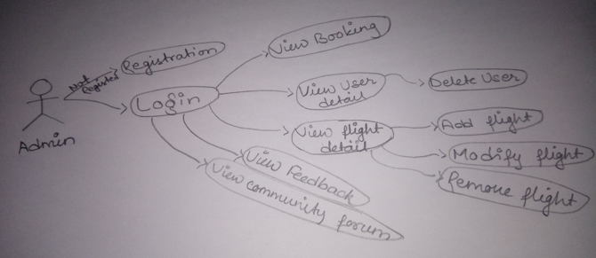

**Figure 1: Rich Picture of Admin**

* User

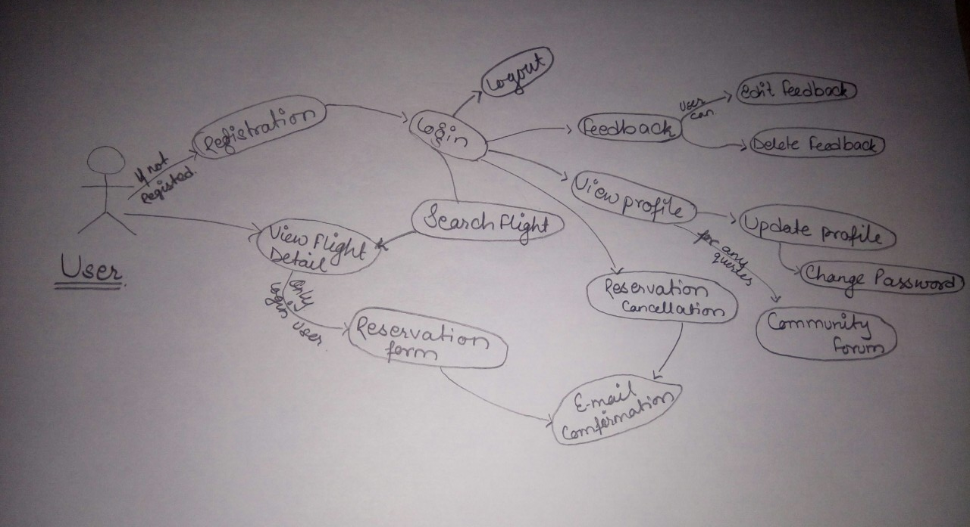

**Figure 2: Rich Picture of User**

**Stage 3: Deriving Root Definitions:**

Root definition is the definition of the definition of the purpose that names a system. These are of short statements that explains the functions and aims of the system needed for its development.

For producing root definitions two steps are included:

1. Input-Output transformation diagrams.

It separates the different purposes of the system and reflects many perspectives.

1. CATWOE framework.

The CATWOE is a checklist for discovering solutions to the problems. It stands for **C**ustomer, **A**ctors, **T**ransformation, **W**orldview, **O**wner and **E**nvironmental. CATWOE Framework is used for producing a root definition for each transformation.

CATWOE analysis have been conducted in my project to give the following result.

**C**= Customers or flight attendees

**A**=Airlines Staffs

**T**=Flight Attendees can directly reserve their flight tickets and communicate with airlines staffs.

**W**=People can save their time of manually going to book their tickets and can spend that time on resourceful tasks

**O**=Airlines System

**E**=Educational Environment

**Root Definition**

A system owned by the Airlines where customers or flight attendees can make reservation of their required tickets online and communicate with airlines staffs gradually saving their time as well as costs that may occur by manually making reservations.

**Stage 4: Deriving Conceptual Models:**

A conceptual model can be defined as a method of analyzing activities that helps in knowing what the actors are needed to perform for the achievement of the transformation. Different activities are listed and related graphically for designing a conceptual model.

The conceptual model for my project is given below.

* Admin

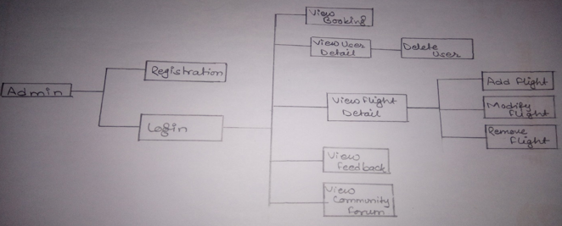

**Figure 3: Conceptual Model of Admin**

* User

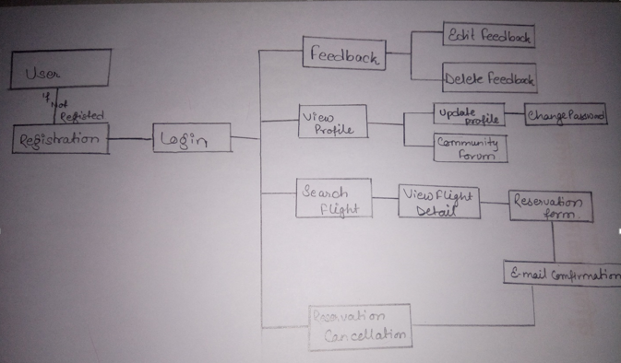

**Figure 4: Conceptual Model of User**

**Stage 5: Comparing Conceptual Models with the Real World:**

In this stages Conceptual model is compared with real world as not all the things are perfect this stage provides a feedback on changes that are needed to be made to existing system.

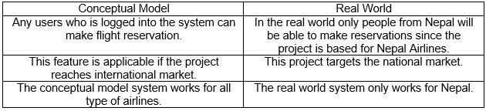

**Figure 5: Difference between Conceptual Model and Real World**

**Stage 6: Analyzing Feasible and Derivable change**

This stage follows the activities to represent the conceptual diagram and rich picture to the stakeholder of the project and some other users who can give helping hand in analyzing the system model with the diagrams shown above. The project has not yet included any features of providing advantages to users who have used the system for a long time. A desirable change that is brought up is to provide feasible facilities to users who are constant users of the online system.

## **2.3 Feasibility Study**

Feasibility study is the initial design step in every project, that combines the elements of knowledge which shows whether the project is possible or not. The gathered knowledge can be determined by understanding the benefits, times and costs related to the project should always have benefits higher than the required cost for the project.

I have performed the varieties of feasibility study in my project. They are shown below in tabular form:

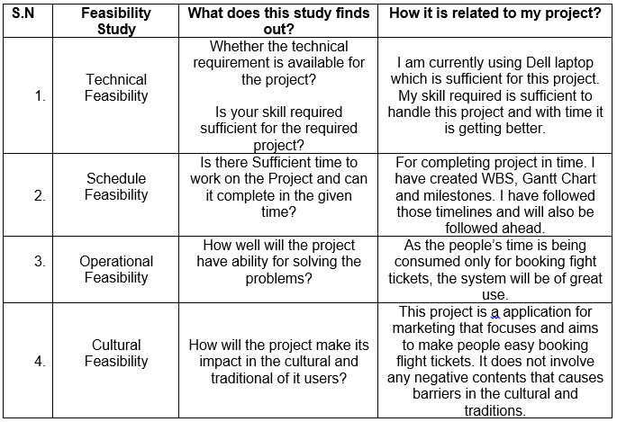

**Figure 6: Table of Feasibility Study 1**

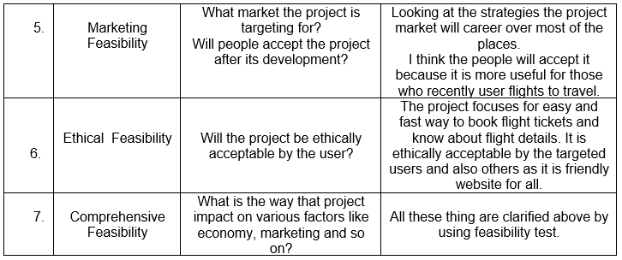

**Figure 7: Table of Feasibility Study 2**

## **2.4 Requirement Analysis**

It is the way of determine the needs of users for the new or modified system so it can satisfy the overall need.

### **2.4.1 Functional Requirement**

Functional requirement are those requirement which are related to systems technical functionality, hard-software for operating as per the system user needs. It helps the users in performing their task easily up to the business requirement.

Functional Requirement of my project is presented below in tabular form including its dependencies and rational.

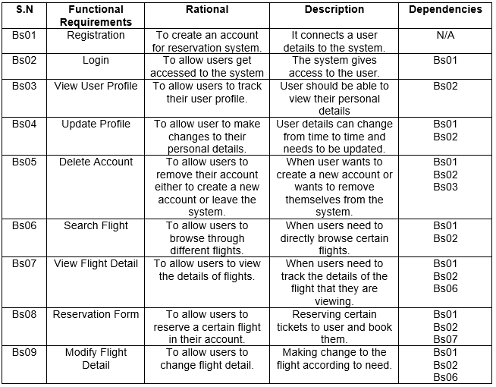

**Figure 8: Table of Functional Requirements 1**

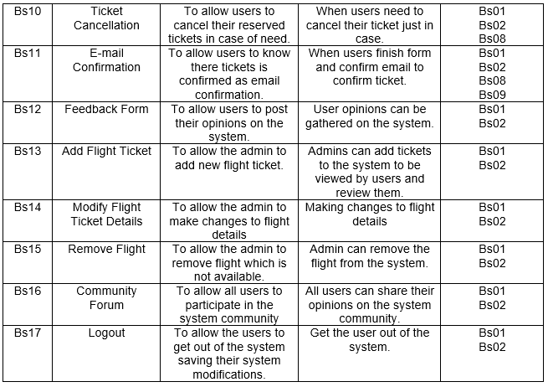

**Figure 9: Table of Functional Requirement 2**

### **2.4.2 Non-Functional Requirement**

Non-Functional requirement are those requirement that specifies criteria which can be used for judging the system’s operation in particular conditions. It is also called “quality attributes” of the system. It determines particular conditions rather than some specific behaviors.

Non-Functional Requirement of my project is presented below in tabular form.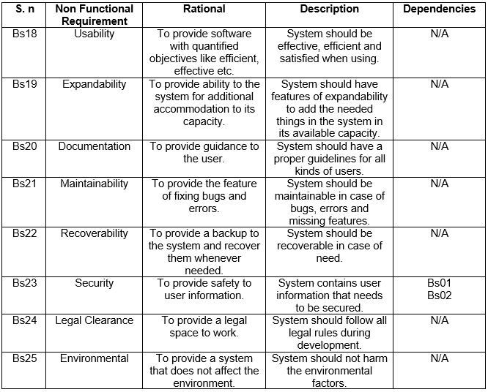

**Figure 10: Table of Non-Functional Requirement**

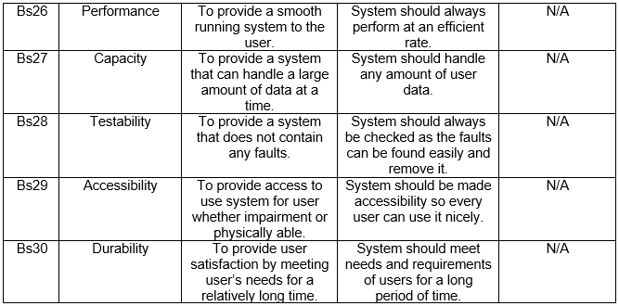

**Figure 11: Table of Non-Functional Requirement 2**

### **2.4.3MoSCoW Prioritization**

MoSCoW prioritization is a prioritization technique which letter stands for must have, should have, could have and won’t have this time. It helps in understanding and managing priorities. Those priorities that are associated with simpler prioritization approaches which are based on relative priorities can be overcome by these techniques.

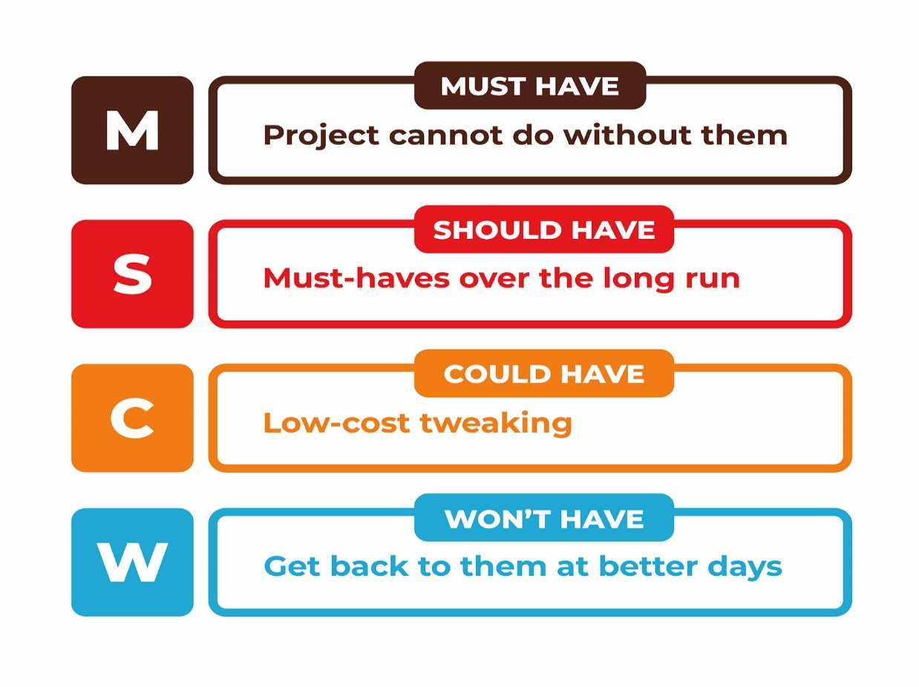

**Figure 12: MoSCoW Prioritization**

* Must Have: It plays a vital role in the project by making it legal, delivering it on the date that is targeted and makes the project secure.
* Should Have: It fixes the minor bug, improves performances but it is not added as without it the project can still run.
* Could Have: Its importance is low but it is the needed requirement for the project.
* Won’t Have: It helps in maintaining expectations about what will not be included in the release of the system.

(ToolsHero, 2019)

The prioritization of various functional requirement is listed below in table:

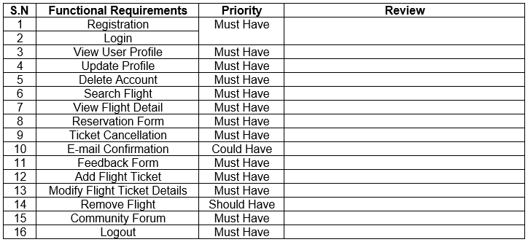

**Figure 13: Table of MoSCoW Prioritization (Functional Requirement)**

The prioritization of various non-functional requirement is listed below in table:

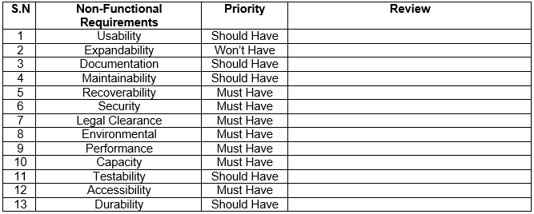

**Figure 14: Table of MoSCoW Prioritization (Non-Functional Requirement)**

### **2.4.4 Software Hardware Requirement (SHP)**

A system requirement specification is a document that is used for capturing the entire complete description on how the system is to be developed. Description about the requirement of software and hardware is given that is need to develop software and it is all produce in response to the requirements of the user.

The hardware and software requirement for this project are listed below:

* Pre-Project Requirements

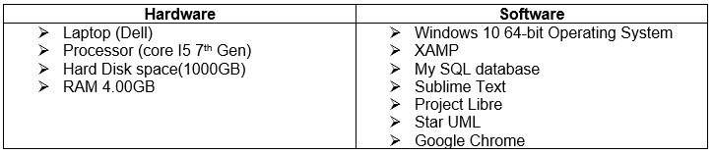

**Figure 15: Pre-Project Requirements**

* Post Project Requirements

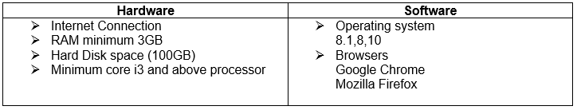

**Figure 16: Post Project Requirements**

## **2.5 Use Case Diagram**

A use case diagram is a graphic representation of the communication or interactions among the system’s element. UML is to show various ways that a user is likely to have interaction with a system.

The purpose of creating use case diagram in my project are listed below:

1. It makes easier and more understandable to represent a system.
2. It helps in identifying any factors which may make the system influence and must be taken into consideration.
3. It shows the relationship of the entities with different functionalities.

The various use case diagrams generated are as follows.

1. Admin Login System

For the use of application and to maintain it an admin must have admin account. They will be able to create a new account by providing their personal details and can login to the system. Registration form can also be opened from the login page as it includes a function for guiding the users to register function. A password can be changed or reset incase if they forgot their password. For all this function the system will guide them to use it.

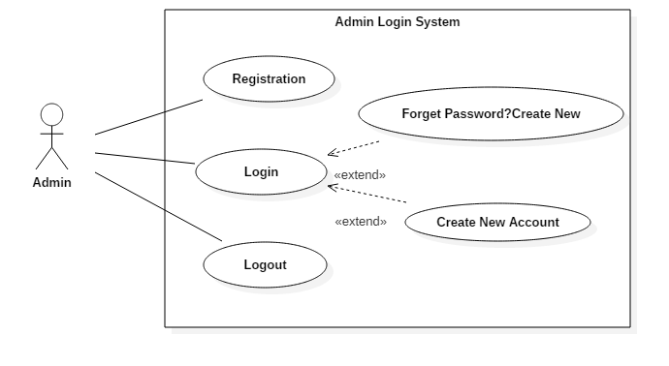

**Figure 17: Admin Login System**

1. User Login System

User will be able to create a new account. If they open login account page without having an account the login page has a function that guides user to the register function so they can login and use the application. If user forgets their password they will be guided for creating a new password.

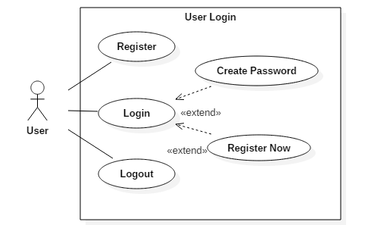

**Figure 18: User Login**

1. User Flights System

Once the users are login they will be able to tickets. Before booking the tickets the users can view flight details, search the flight that they want to view flight available and then book flight tickets. The users can also cancel their booking if they are willing to do it.

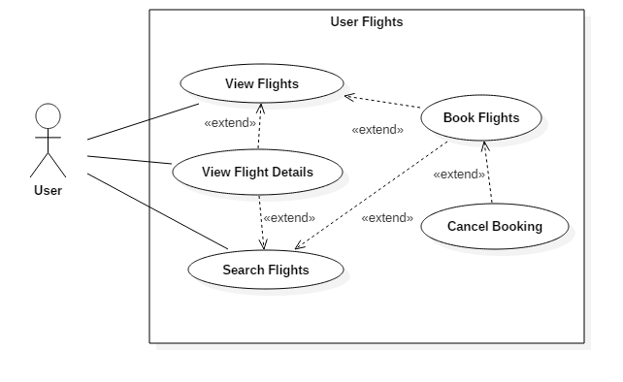

**Figure 19: User Flights**

1. User and Admin Profile

Both admin and user will be able to view their profile. They can make changes in their account profile. They can update their any personal details as well. But admin only can be able to delete their account which will remove from the system.

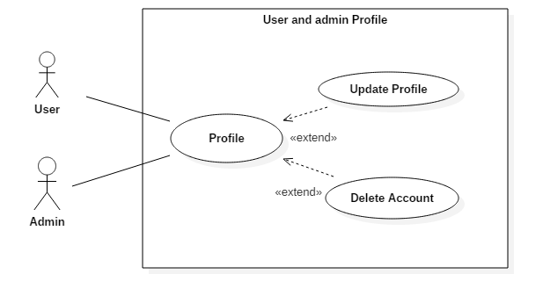

**Figure 20: User and admin Profile**

## **2.6 Natural Language Analysis**

Airline Reservation System is a project that focuses on marketing the companies of airlines related to its best facilities on booking flights. Statistics shows that air way is one of the most used transportation in this 21st century. Whether it be a short distance or a long distance air way is chosen by many people.

The companies are looking ahead for some better Airline Reservation System. The system should permit admin and users to register their new account inserting their personal details and after that they can login into the system. Incase if any of the user are facing the problem in technologies, the admin can add users and help them in reservation flights. User should have ability to manage their account by editing or updating in their account only after login. Admin should also have that ability to manage their account and also have to view all the user that are registered and can delete users account in case they act in a vulnerable way to the company. The feature of creating new password must be available so that if the password is forgot a new can be created easily and can be logged in to the system.

Once the user is login into the system it must allow the user to update profile, search flight, view flight details and book flights tickets. More importantly the user must also have the ability to cancel their reservation. For payment it is done after receiving the ticket.

For the system to be highly efficient some details are needed. They are given below:

* Admin and User username, password.
* Flights name, departure time, arrival time, seats number.

This project will be online based which will solve the problems mentioned above and provide better Airline Reservation System to the computer.



**Figure 21: Table of Class, Attributes and Methods**

**Initial Class Diagram**

Initial class diagram is a standardized model that explain an object oriented programming approach. It shows data models for information system whether it is simple or complex. It representing system’s attributes, classes, operations and the relationships between objects. It can be used by business analyst to model system from business thoughts.

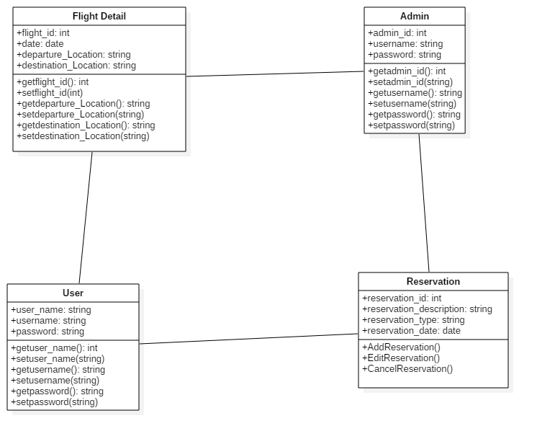

**Figure 22: Initial Class Diagram**

# **Chapter: 3 Design**

## **3.1 Introduction to Design**

Design is one of the step that is completed which developing a software which has a user’s perspective and drives development that is based on specific needs of customer. Every process of design is different in various projects and fields of design. In software the design transforms every requirements of used into suitable form so the programmer could find it easy in the software coding and implementation.

For this project, I have used five different models which are explain below:

### **3.1.1 Class Diagram**

A class diagram is an illustration that describes the system’s structure by representing classes, attributes, operation/methods of systems and the relationships among object. Classes consists of various access level control by the access modifier that is public (+) and private (-). The class diagram consists of three different compartments.

The importance of performing class diagram in my project are:

* It helps in modelling the static view of an application.
* It can be used in time of construction and explains system’s responsibilities.
* It helps the programmer in the software coding and implementation.

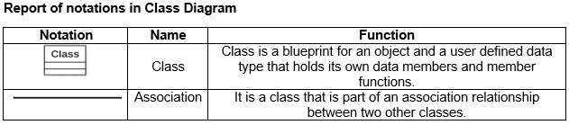

**Figure 23: Report of notations in Class Diagram**

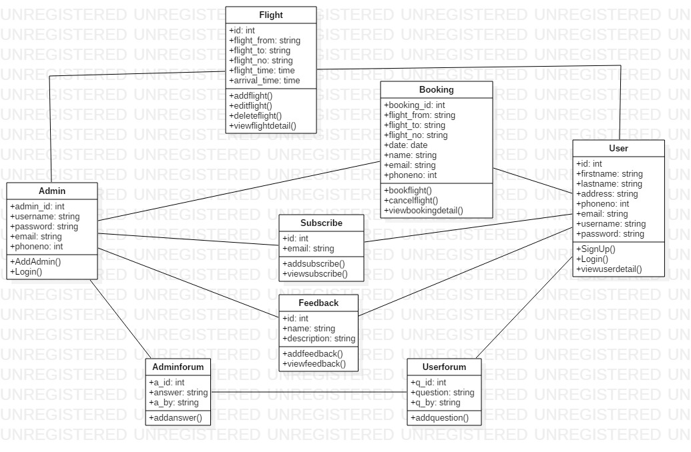

**Figure 24: Final Class Diagram**

To know my system well such as its class, attributes, methods and it's boundary I have chosen the class diagram. The class diagram provides the overview of the system by representing its objects and classes. There are eight classes in my system. They are Flight, Booking, User, Userform, Admin, Adminform, Subscribe, and Feedback. In all the classes, there attributes and the operation within its class are shown properly.

### **3.1.2 Data Flow Diagram**

A Data Flow Diagram is a visual description which represents the information that flows between various processes within a system. A neat, clear and nice data flow diagram can show a good amount of the system requirements graphically. The diagram can be automated, manual or the combination of both.

The importance of performing data flow diagram in my project are as follows:

* It helps in explaining the boundaries of the system.
* It helps to show the users how the data moves within a system.
* It is easy to understand for both technical and non-technical people.

(Visual-paradigm.com, 2019)

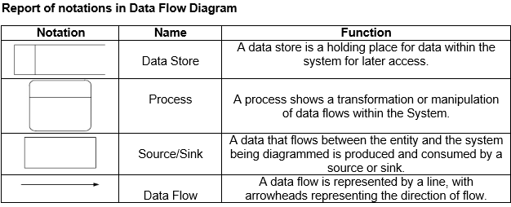

**Figure 25: Report of notations in Data Flow Diagram**

**Login and Registration Data Flow Diagram**

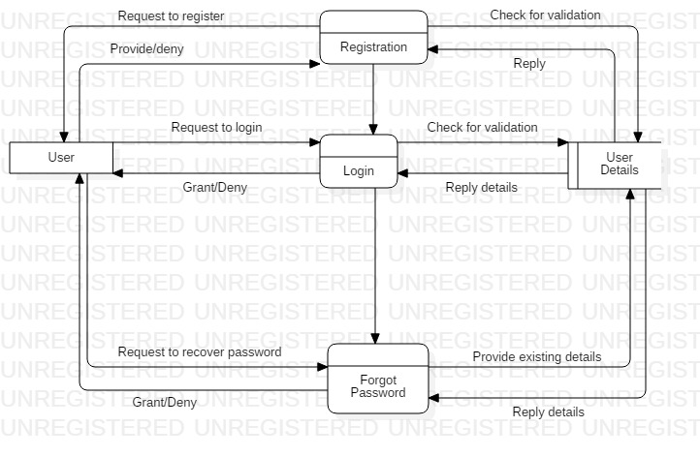

**Figure 26: Data Flow Diagram (Login and Registration)**

In the above Data Flow Diagram users are firstly requested to register for creating an account linked with the system by giving users details. Now they can get access into the system by providing the registered details and needed details. If the users forget the password, the system will help them in creating a new password, but only after the validation of their account ownership.

**Admin Action Data Flow Diagram**

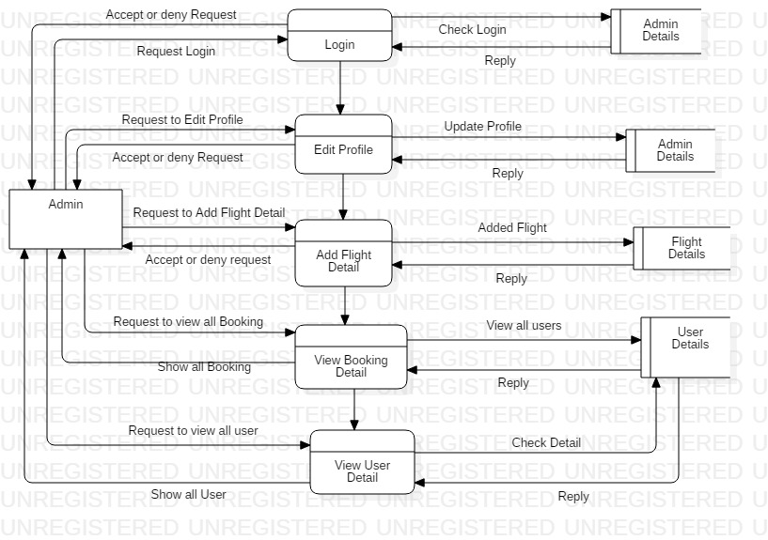

**Figure 27: Data Flow Diagram (Admin Action)**

In the above DFD diagram, same like of the users, admin will also have the ability to login into the system, view admin details, flight details, and edit their profile. But the admin will have more additional ability than of the users. Admin will be able to add flight detail, view the booking details of the users, and also view the user details.

**User Action Data Flow Diagram**

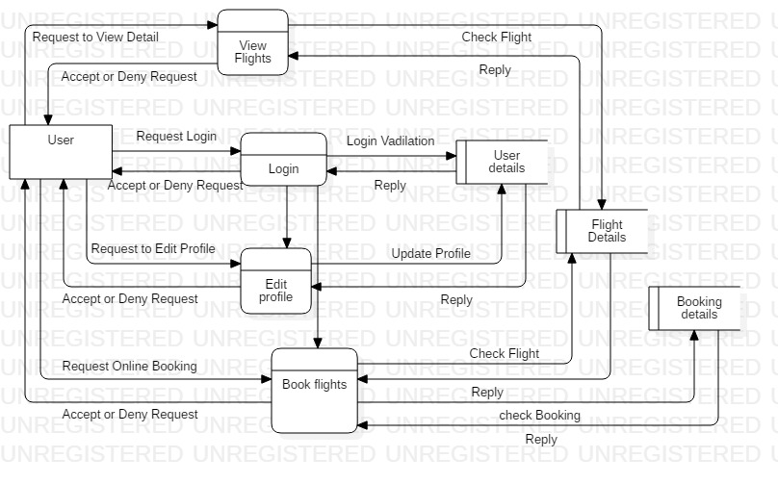

**Figure 28: Data Flow Diagram (User Action)**

In the above DFD diagram, every users will be able to view the flights details. After the access to the system users can view their details, and they will also have the ability to edit their profile. They can also book the flights and view the booking details. For the successful complete of the function the users request has to be accepted in each process.

## **3.2 Behavior Modelling**

Behavioral Model refers to the use of data that are available and the use of data spend relevant by consumer and business for the estimation of future behavior.

### **3.2.1 Activity Diagram**

Activity diagram is a flowchart that represents actions and flow of control in a system. This diagram can also explain the steps that are in use case diagram.

The importance of performing activity diagram in my project are as follows:

* It helps in describing the logic of an operation.
* It records the logic of business in a simple way that makes easy in communicating the complexity of business logic with all the stake holders.
* It is simple in understanding for all the end users.

(Smartdraw.com, 2019)

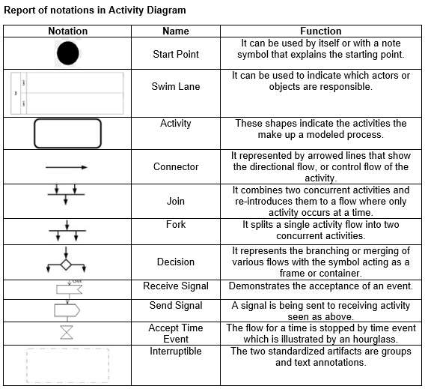

**Figure 29: Report of notation in Activity Diagram 1**

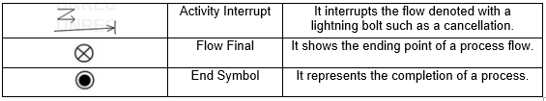

**Figure 30: Report of notation in Activity Diagram 2**

**Login and Registration**

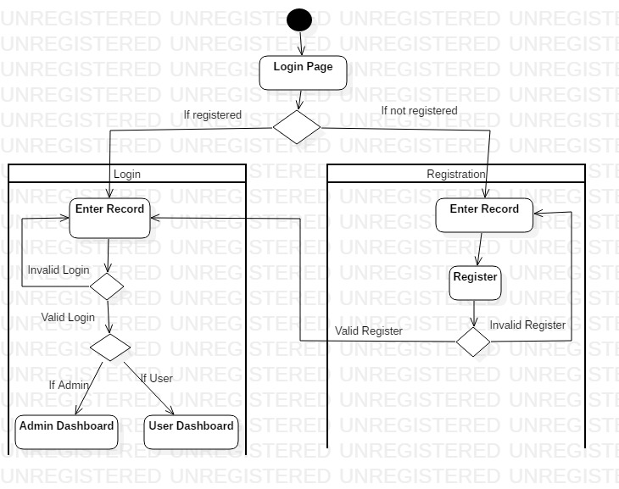

**Figure 31: Activity Diagram (Login and Registration)**

In the above activity diagram, the activity of the users starts from the login page. After entering the login page a decision notation will separate two different conditions for the registered and unregistered users. If the user is not registered, a registration form will be opened where the details will be provided by users, and if in case there is error in the registration form the user will be taken back to beginning and if the registration is valid the user will be taken to the login page. After the completion of the registration and if the user is registered from the first the user will enter the login page where the successful login will take the user to the admin or user dashboard according to the role they have in the database and the login is unsuccessful the user will be taken back to the beginning of the login page.

**Admin Dashboard**

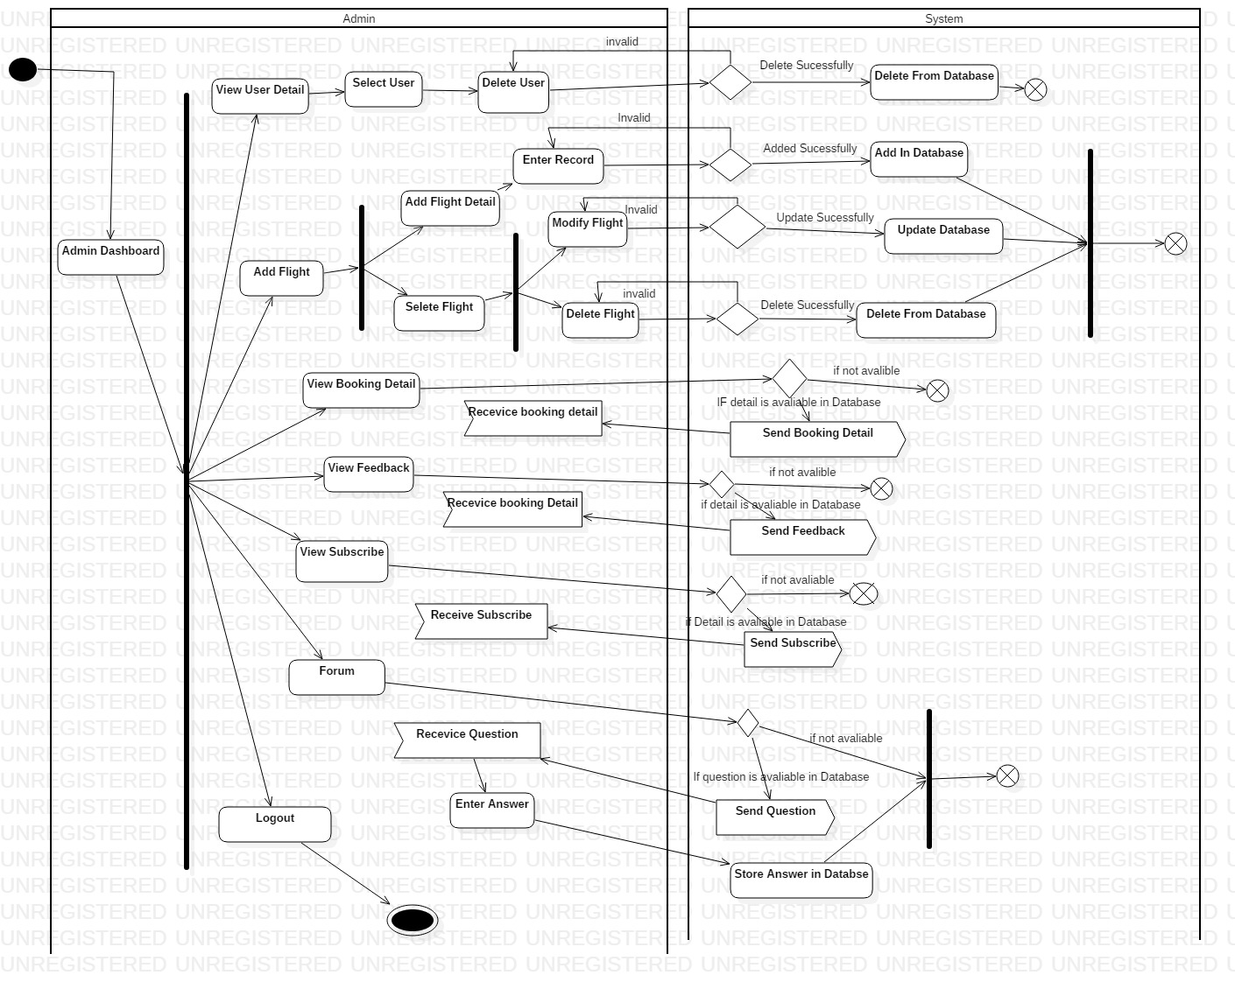

**Figure 32: Activity Diagram (Admin Dashboard)**

When the user is taken into the admin dashboard after the successful login, admin can perform various tasks as illustrated by the fork notation. Briefly, admin can change the profile of the user and can make changes in the database with permission from the system. Admin can view booking detail, feedback, subscribe, receive questions and enter answers.

**User Dashboard**

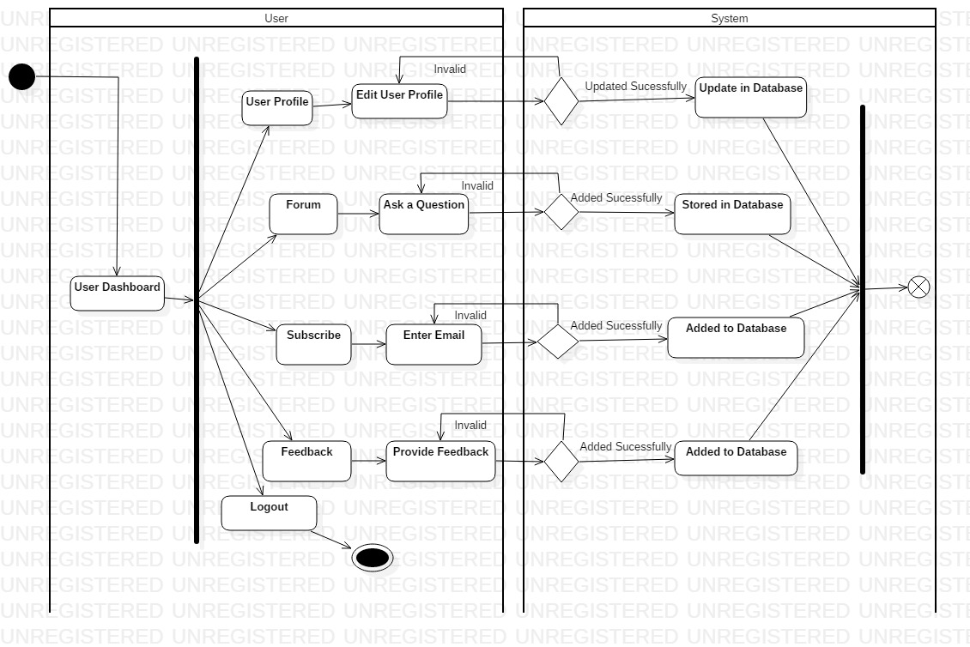

**Figure 33: Activity Diagram (User Dashboard)**

With the user already being logged into the system, the user will be able to edit their profile which will be update in database. They can ask question. The user can subscribe the application by entering their email, and also they can provide feedback.

**User Booking Flight**

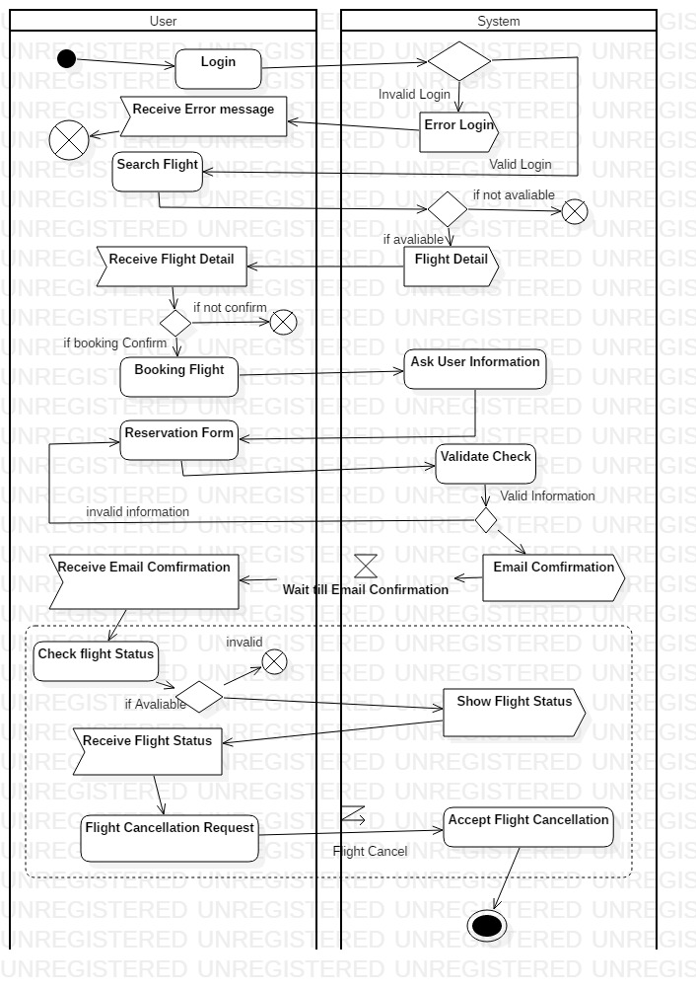

**Figure 34: Activity Diagram (User Booking)**

Now the user login into the system with incorrect detail will provide them error message and if the login is correct the user will be taken to their homepage. In homepage they can search for the flight and receive flight detail if it is available. In the booking term, the user can booking flight but for its confirmation the user is asked for their information, fill reservation form where the system will check whether it is valid or not which will provide email confirmation to the user. They can also check flight status if available and also request the system for the flight cancellation.

### **3.2.2 Sequence Diagram**

Sequence diagram is commonly used interaction diagram. It shows the interaction between objects in a sequential order in which the interaction takes place. It also describes how and in what order the objects in a system function.

The importance of performing sequential diagram in my project are as follows:

* It is used to document a requirements of the system and for flushing out the design of system.
* It helps in modelling the flow of logic within a system in a visual manner.
* It also represents the messages that are exchanged between the objects needed for carrying out the functionality.

**(**GeeksforGeeks, 2019)

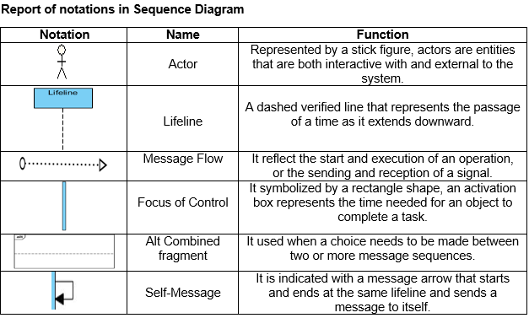

**Figure 35: Report of notation in Sequence Diagram**

**Login and Registration**

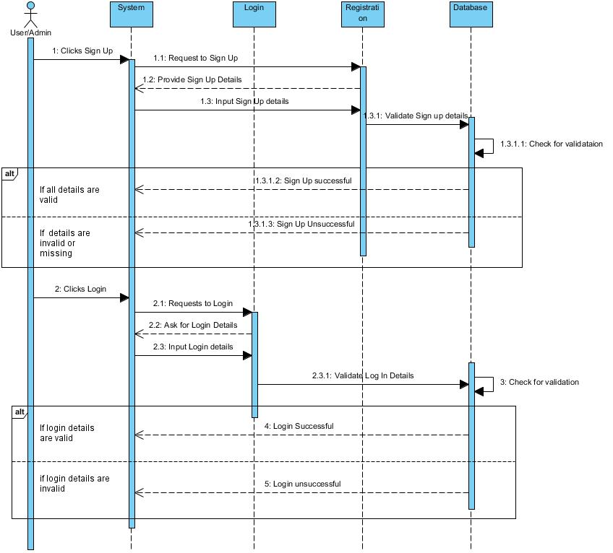

**Figure 36: Sequence Diagram (Login and Registration)**

Here, the user will firstly reach for the signup/login form in which after a click on it the system will provide them a form where the user will be filling their details. After the form is filled and submitted, the system will check for the validation in the database. If the validation is correct, the system will sent a message of successful login or successful signup, otherwise the system will sent a message of unsuccessful login or unsuccessful signup if the validation is incorrect.

**Admin Dashboard**

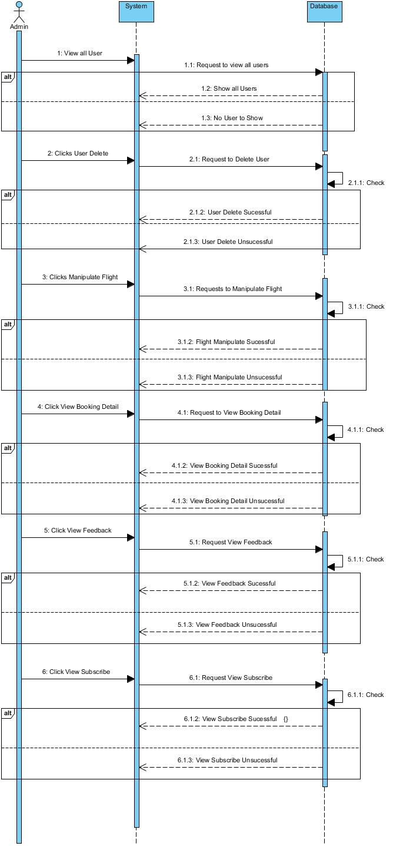

**Figure 37: Sequence Diagram (Admin Dashboard)**

The actions or functions that the admin performed will first be requested by the system to the particular page of the database. And if the page is validate the database will carry out the requested actions and sent the message of actions completed successful else the message of actions completed unsuccessful. All the actions that admin can do is manipulate the flights, view users details and even delete their details, view booking details, view subscribe and view feedback.

**User Dashboard**

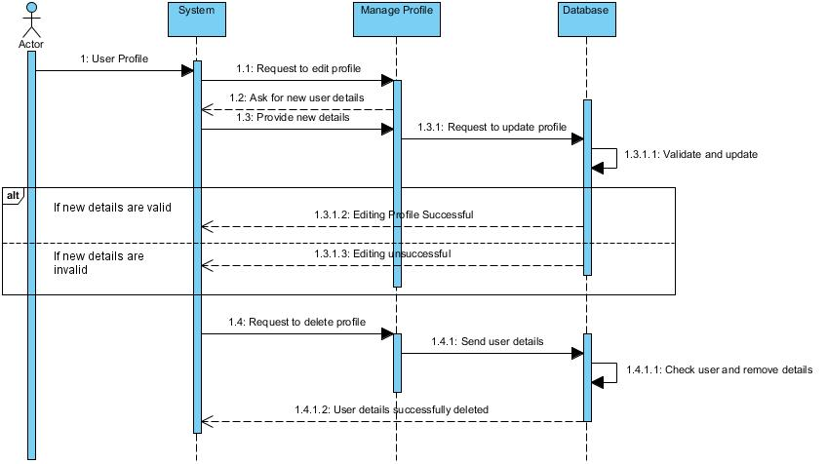

**Figure 38: Sequence Diagram (User dashboard)**

If the user want to perform the action in their profile on editing and deleting then in beginning the users action will be requested by the system to manage profile where the user will be asked for a new user details to enter. The entered details will be sent to database which will be checked for validation and after that the message will be sent as editing profile successful if the validation is correct else editing profile unsuccessful. And in case of deleting the user profile the system will request to the manage profile which will sent user details to the database where user detail will be checked and removed. After the action is completed a message will be sent as user details successfully deleted.

**Booking**

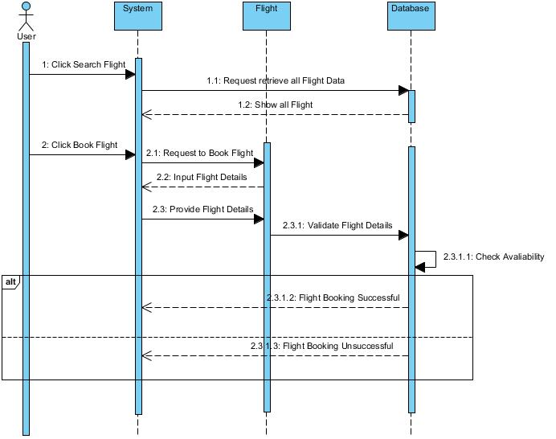

**Figure 39: Sequence Diagram (Booking)**

In the booking term, the user will be able to search for a flight and book their flight. The user action will be requested by the system to the flight and then to the database. All the flights will be shown if there is any flight available. When booking the flight system will request to the flight where the user will be asked to input the flight details and the provided flight details will be sent in the database for the validation. If the validation is correct a message will be sent as flight booking successful else flight booking unsuccessful.

## **3.3 Database Modelling**

A database model illustrates to the logical structure, layout of a database which also includes relationships that decides how can the data be stored, managed and accessed within it.

### **3.3.1 Data Dictionary**

Data dictionary is a set of file containing a metadata of database. It holds the records likewise, ownership of data, relationship of data to other objects etc.

The importance of performing data dictionary in my project are as follows:

* It enables every available users to share common opinion of the data resource.
* It provides clear understanding of data elements.
* It helps in understanding the requirement and design of the system of the great extent.

(Tutorialcup.com, 2019)

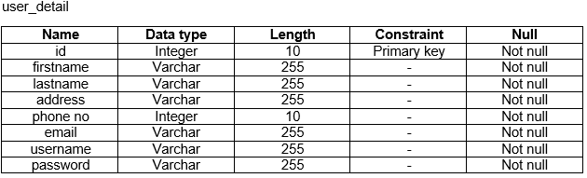

**Figure 40: Data Dictionary of user_detail**

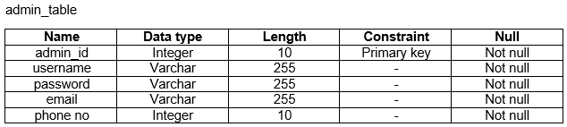

**Figure 41: Data Dictionary of admin_table**

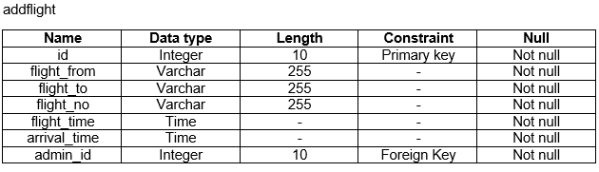

**Figure 42: Data Dictionary of addflight**

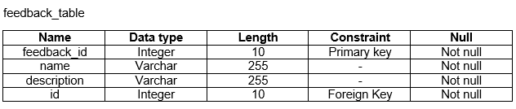

**Figure 43: Data Dictionary of feedback_table**

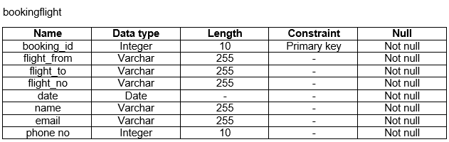

**Figure 44: Data Dictionary of bookingflight**

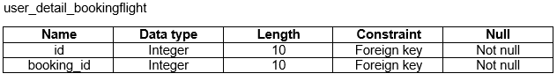

**Figure 45: Data Dictionary of user_detail_bookingflight**

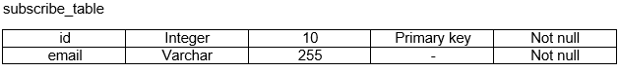

**Figure 46: Data Dictionary of subscribe_table**

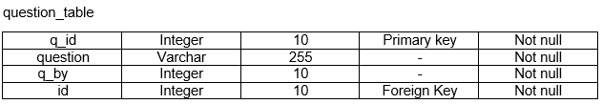

**Figure 47: Data Dictionary of question_table**

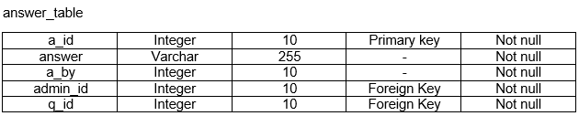

**Figure 48: Data Dictionary of answer_table**

### **3.3.2 ER Diagram**

An entity-relationship diagram (ER diagram) is extremely important to develop a database design and is a visual representation of the system’s database. It shows the entities of the system and the relationship between those entities.

The importance of performing ER diagram in my project are as follows:

* It is helpful for doing documentation of the database design.
* It is easy to understand
* It helps in communicating the logical structure of the database to the users.

(Diligent Insights, 2019)

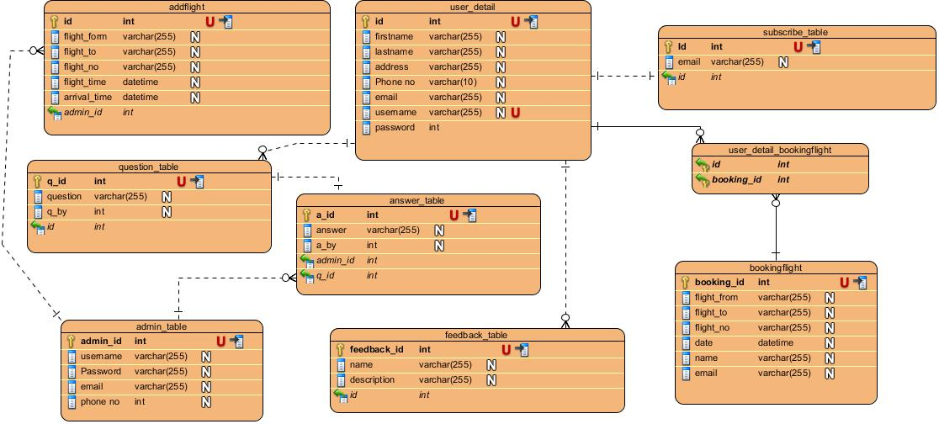

**Figure 49: Entity Relationship Diagram**

## **3.4 Architectural Model**

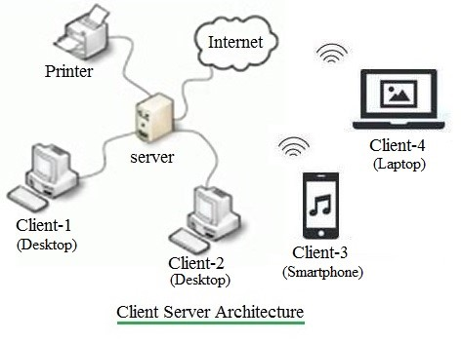

**Figure 50: Client Server Architecture**

The model used to represent the structure of the overall network used by the system is known as architectural model. For my project I am using the client server architecture. This architecture allows one or more clients systems to a centrally located server. The server holds the responsibility of controlling the services given to its clients.

The justifications for using this model in my project.

* Customers as well as the airlines system will have distinct and specific tasks.
* All data are in a centralized location, so recovering and backing up data is easy.
* Changes can be made easily in a centrally located data.

## **3.5 Prototype Design**

It refers to the duplicate of any objects before the actual object is created. I have used Balsamic mockup in this project. It is a user interface design tool, and faster.

The importance of performing prototype design in my project are as follows:

* It permits us to hide the difficulty of creating new instances from the client.
* It helps in reducing the time and costs.
* It helps in improving the quality of requirements and specifications given to the users. (JC Metalworks, 2019)

1. Home Page

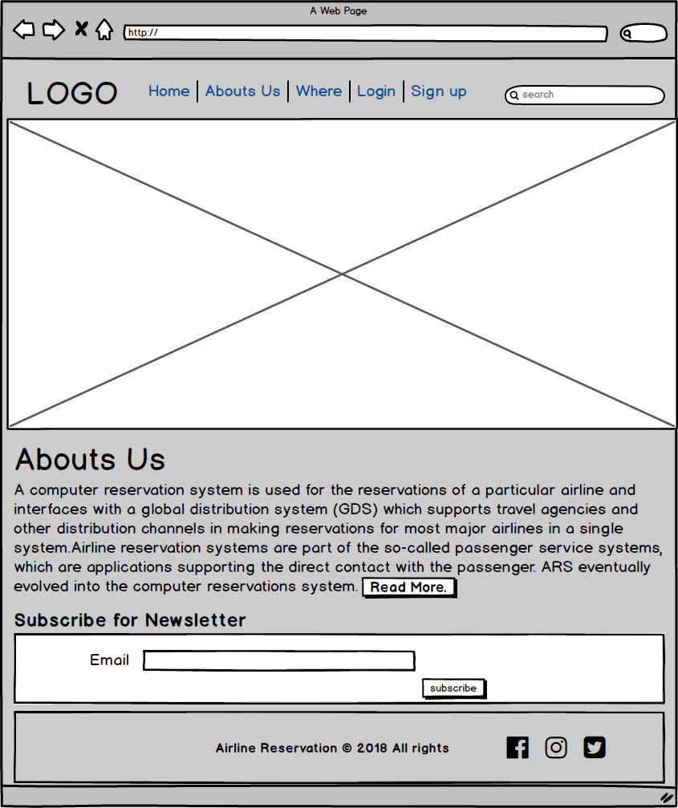

**Figure 51: Protype of Home Page**

1. About Us

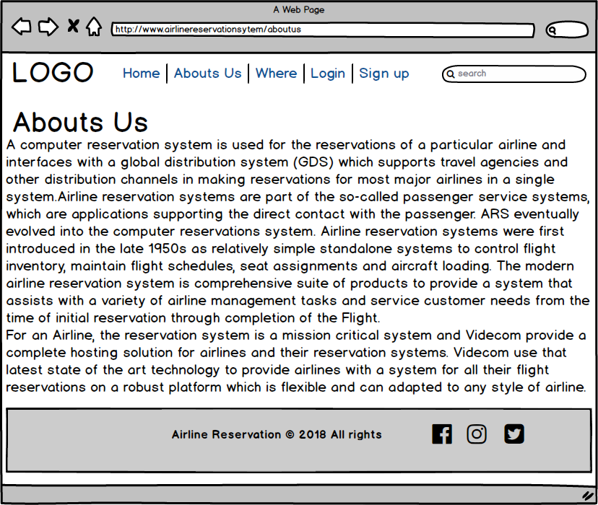

**Figure 52: Protype of About Us**

1. Register

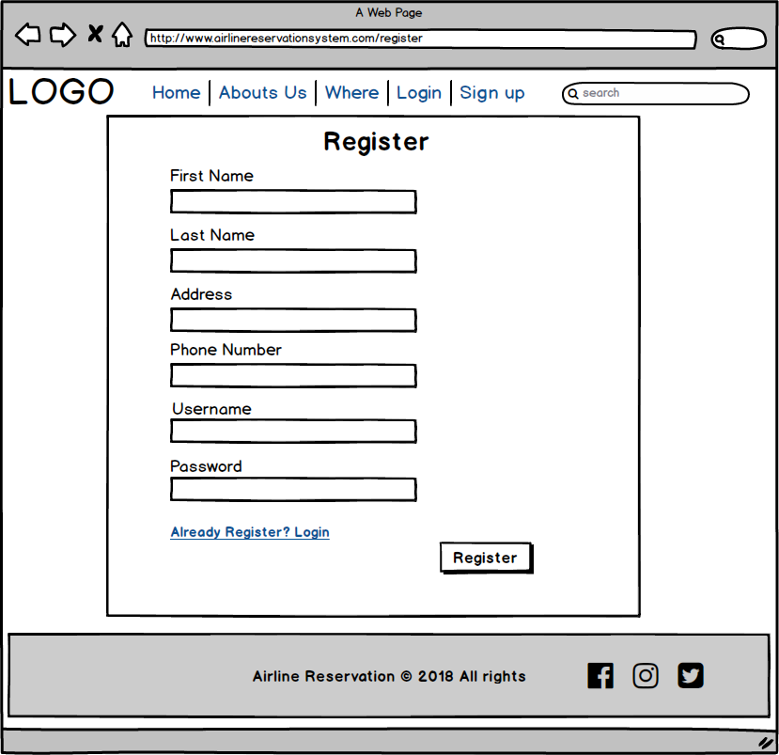

**Figure 53: Protype of Register**

1. Login

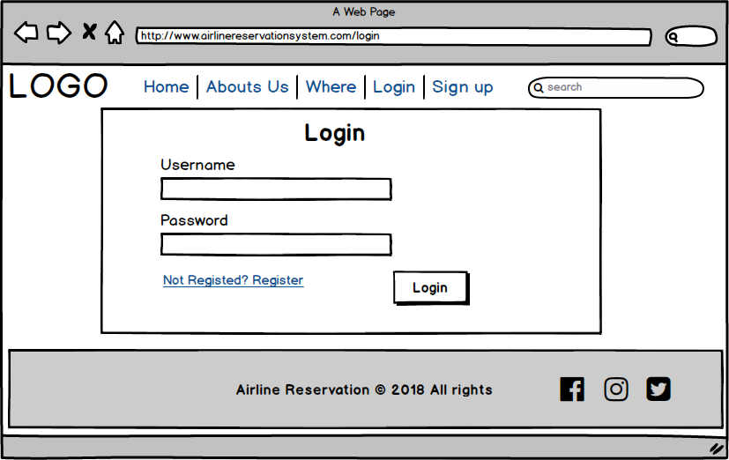

**Figure 54: Protype of Login**

1. Admin Dashboard

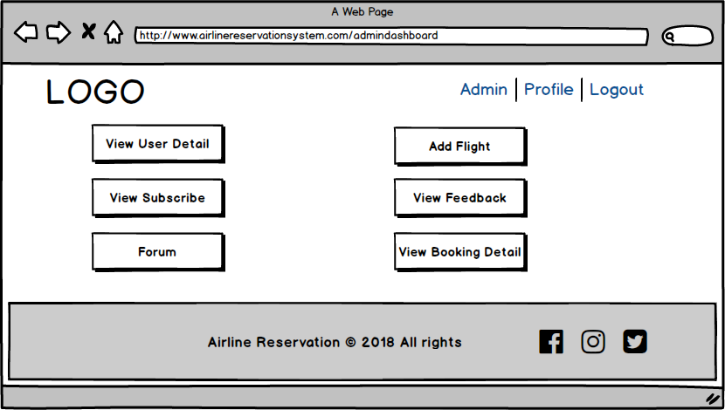

**Figure 55: Protype of Admin Dashboard**

1. View User Detail

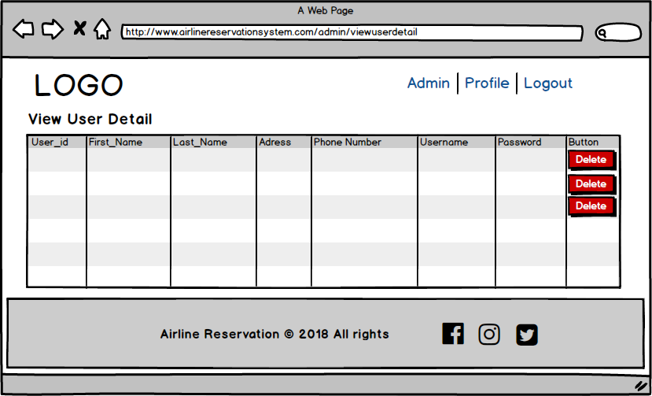

**Figure 56: Protype of Protype of View User Detail**

1. Add Flight

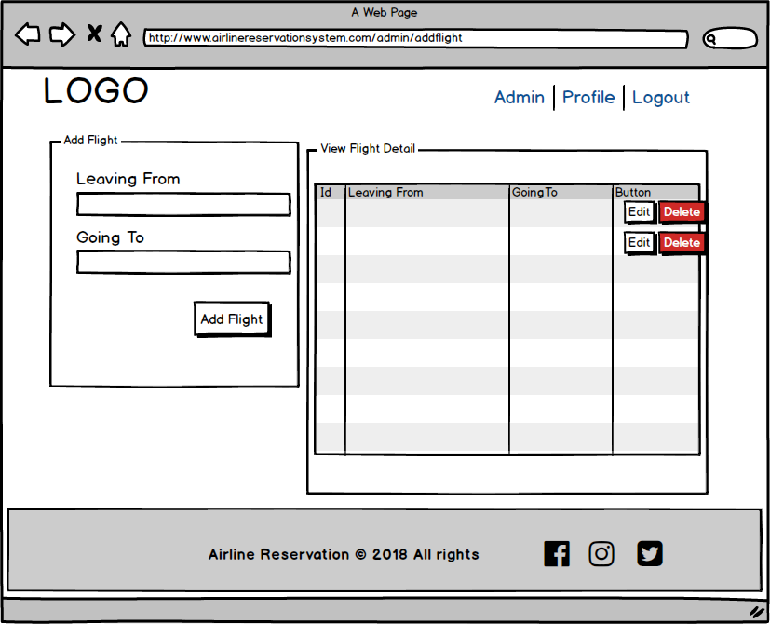

**Figure 57: Protype of Add Flight**

1. Edit flight

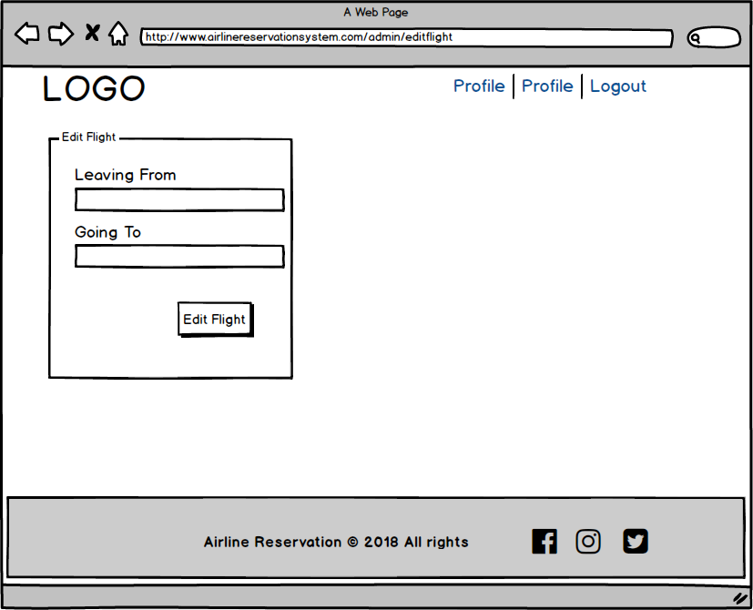

**Figure 58: Protype of Edit Flight**

1. Forum

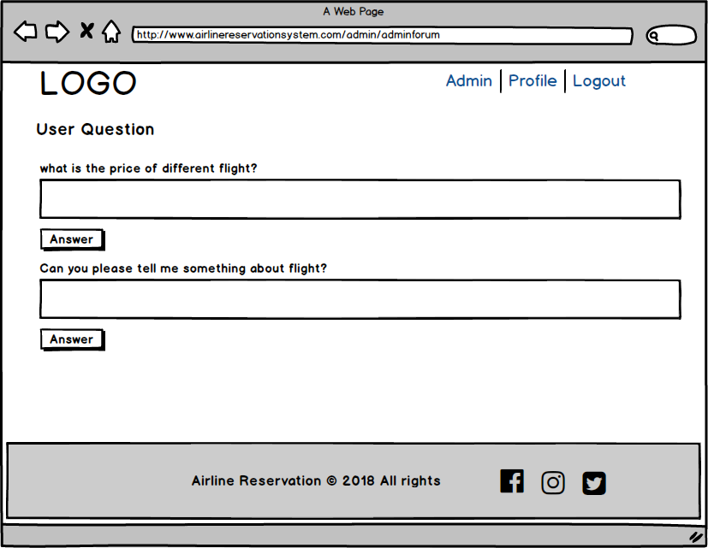

**Figure 59: Protype of Forum**

1. View Feedback

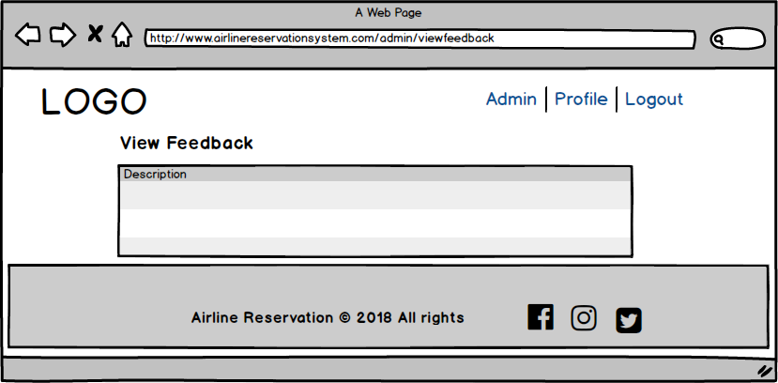

**Figure 60: Protype of View Feedback**

1. View Subscribe

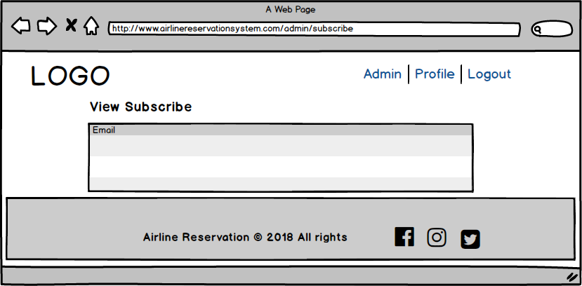

**Figure 61: Protype of View Subscribe**

1. Admin Profile

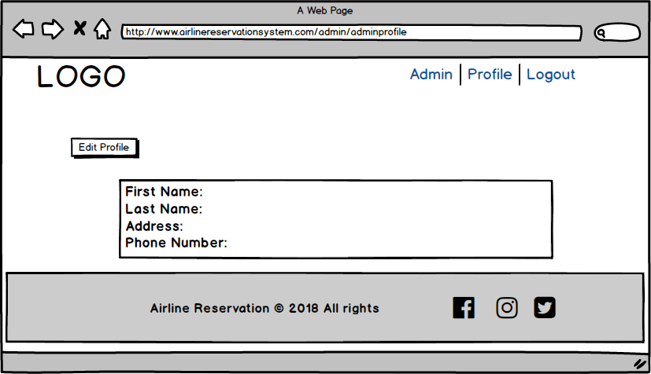

**Figure 62: Protype of Admin Profile**

1. Edit Profile

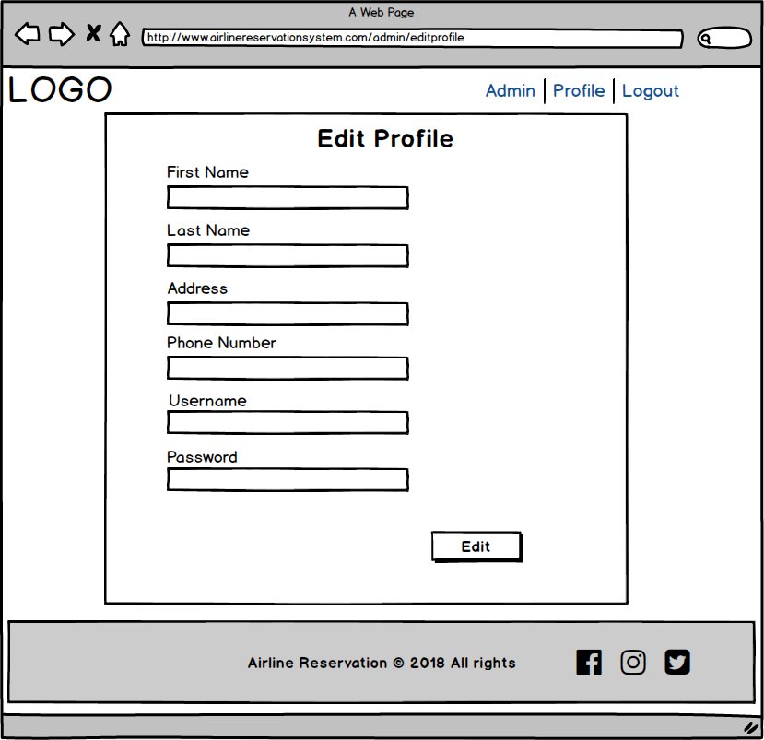

**Figure 63: Protype of Edit Profile**

1. User dashboard

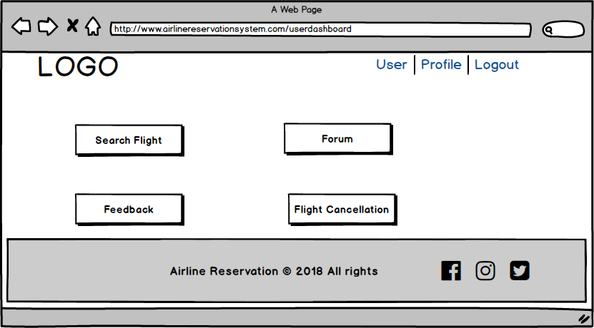

**Figure 64: Protype of User Dashboard**

1. Booking

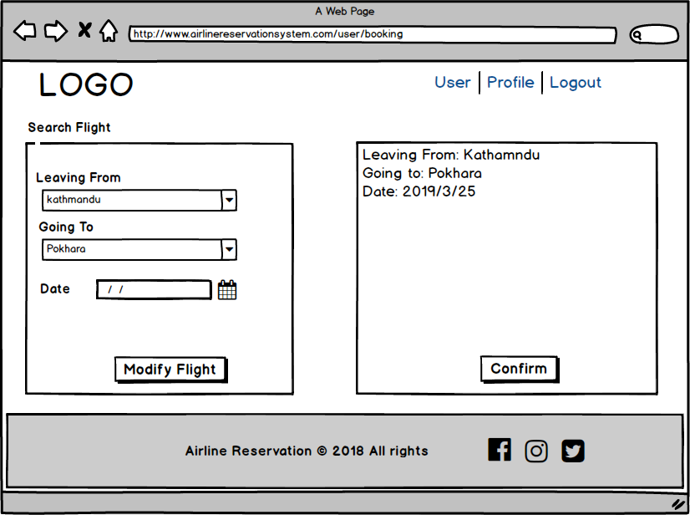

**Figure 65: Protype of Booking**

1. Feedback

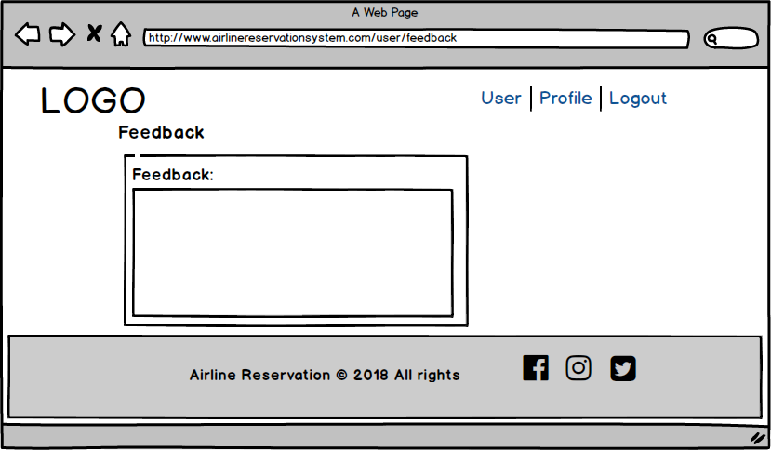

**Figure 66: Protype of Feedback**

1. Forum

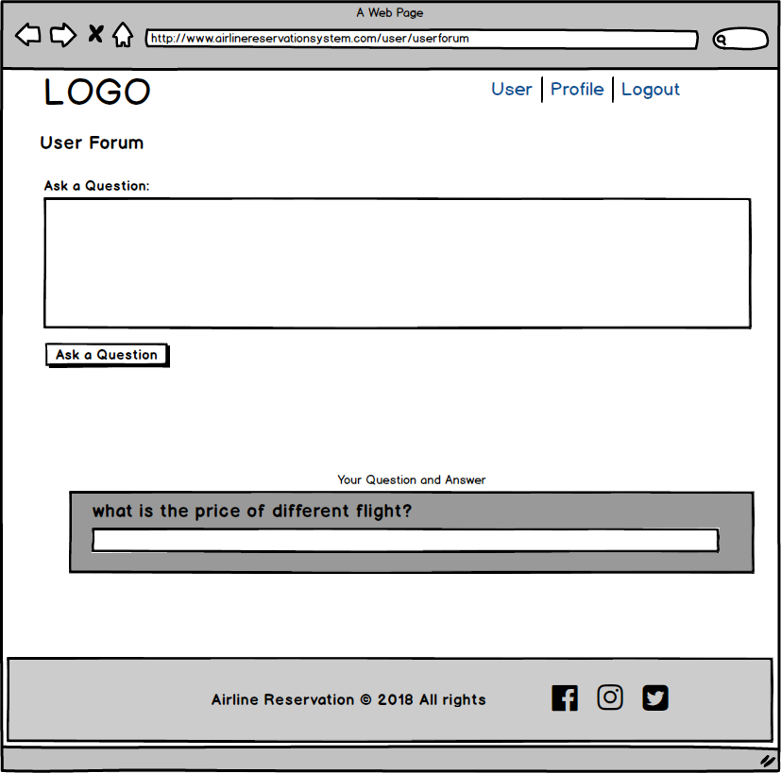

**Figure 67: Protype of Forum**

1. User Profile

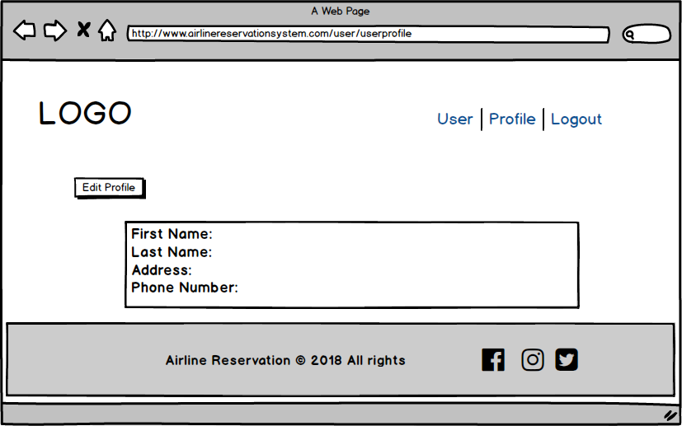

**Figure 68: Protype of User Profile**

1. Edit Profile

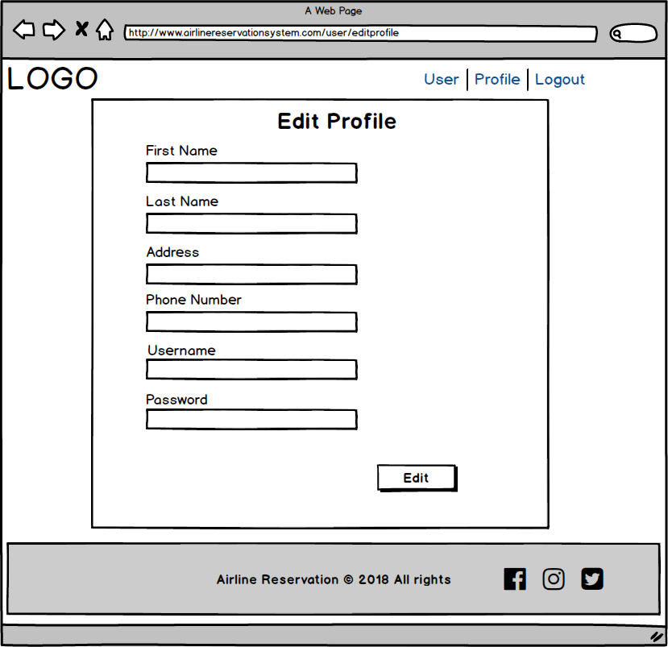

**Figure 69: Protype of Edit Profile**

1. Flight Cancellation

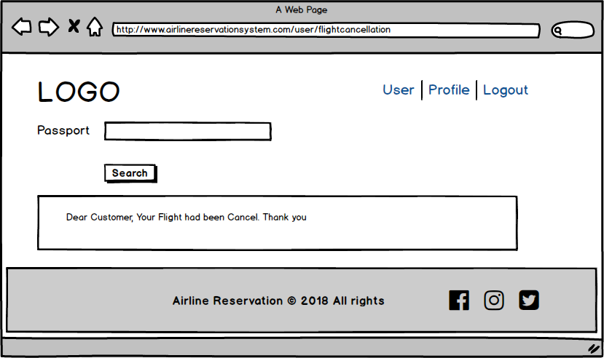

**Figure 70: Protype of Flight Cancellation**

1. Where

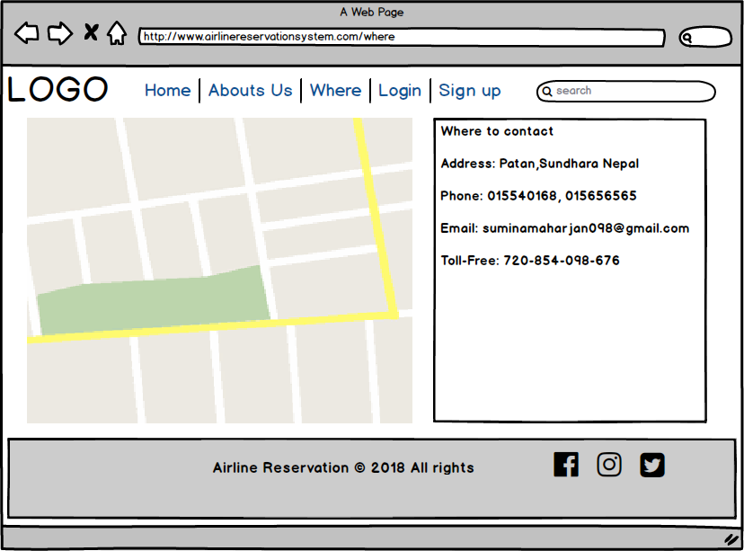

**Figure 71: Protype of Where**

# **Chapter: 4 Implementation**

## **4.1 Introduction to Implementation**

Implementation is the fourth phase in my project. It is the process where the designed system is carried out for doing something. Implementation is important because it helps in the accomplishment of systems goals and objectives. Across the system implementation helps in enabling the sustained curriculum development. I have used PHP Object Oriented Programming language in my project.

Here, is the screenshot of code with UI design.

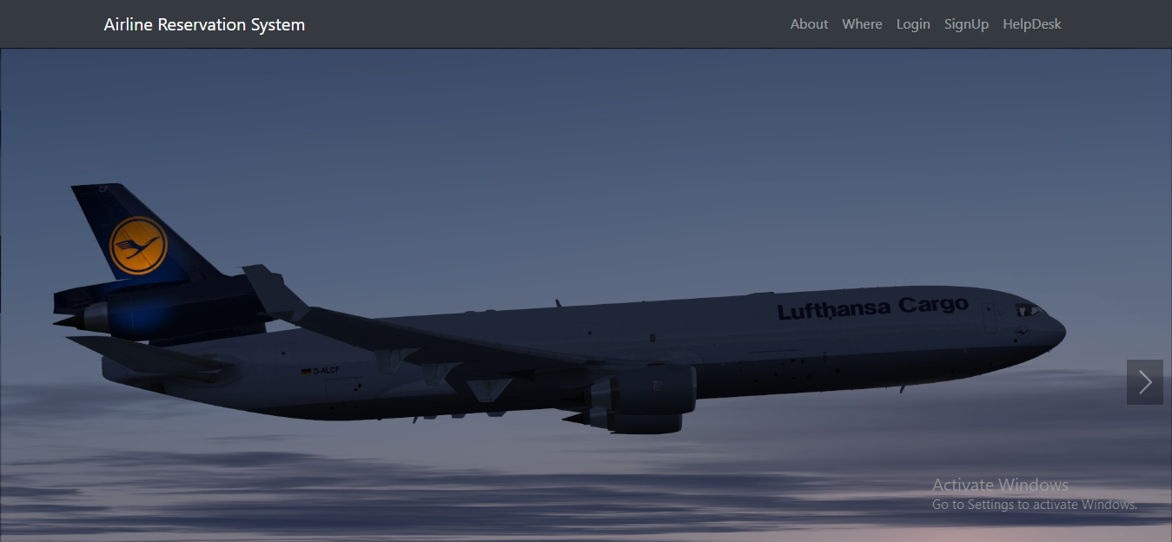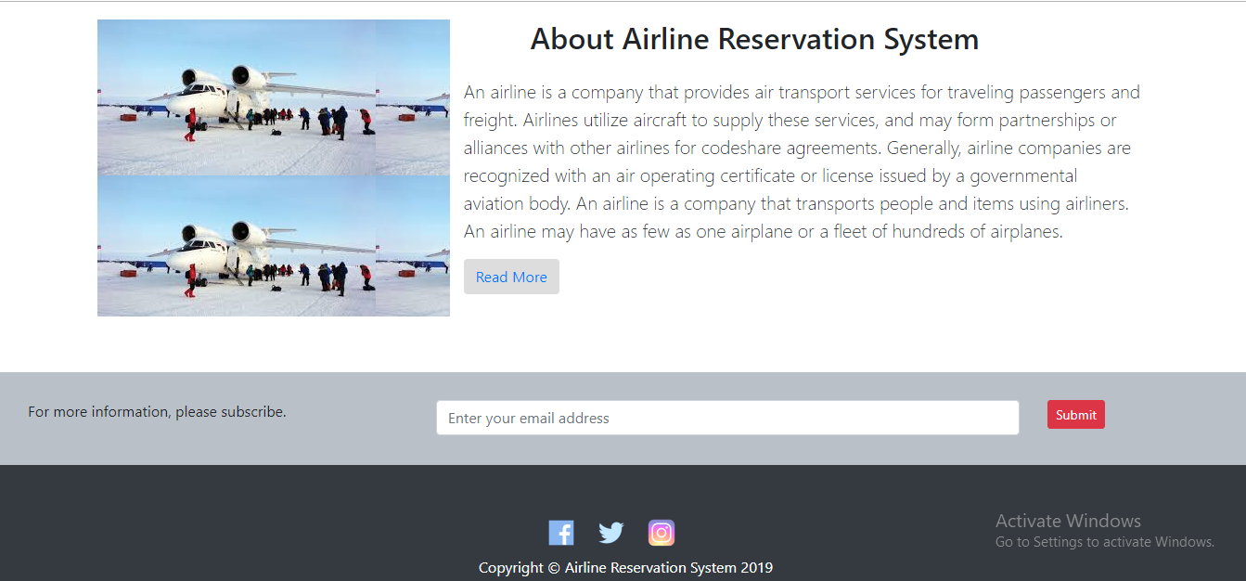

**Figure 72: Website of Home Page**

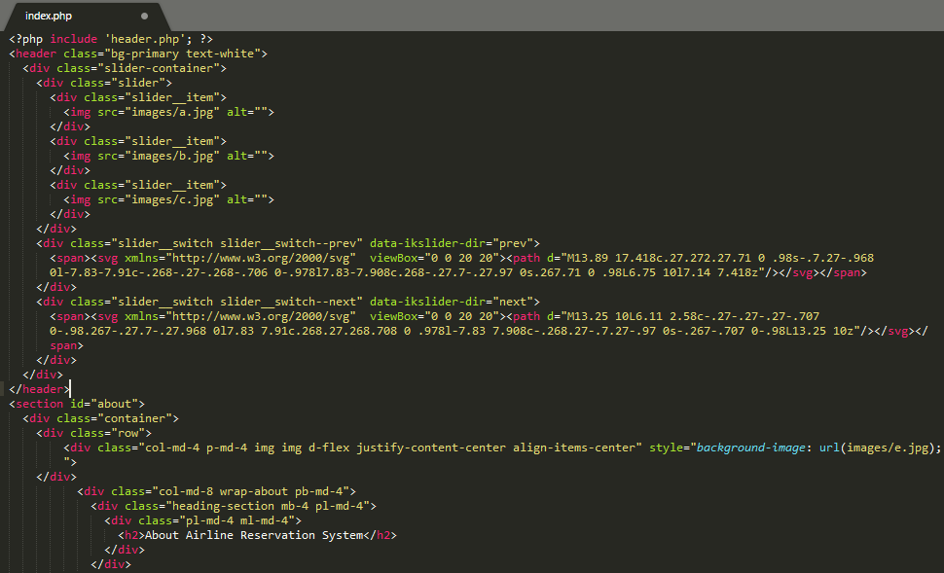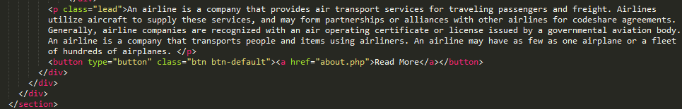



**Figure 73: Website of Subscribe Form**

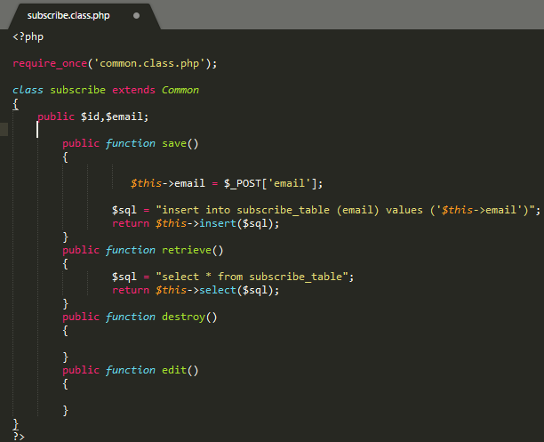

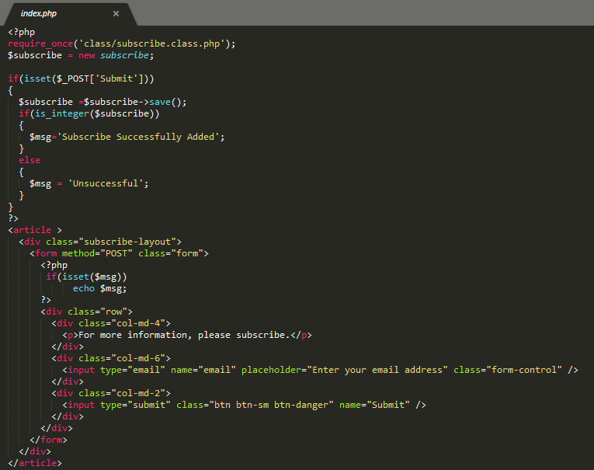

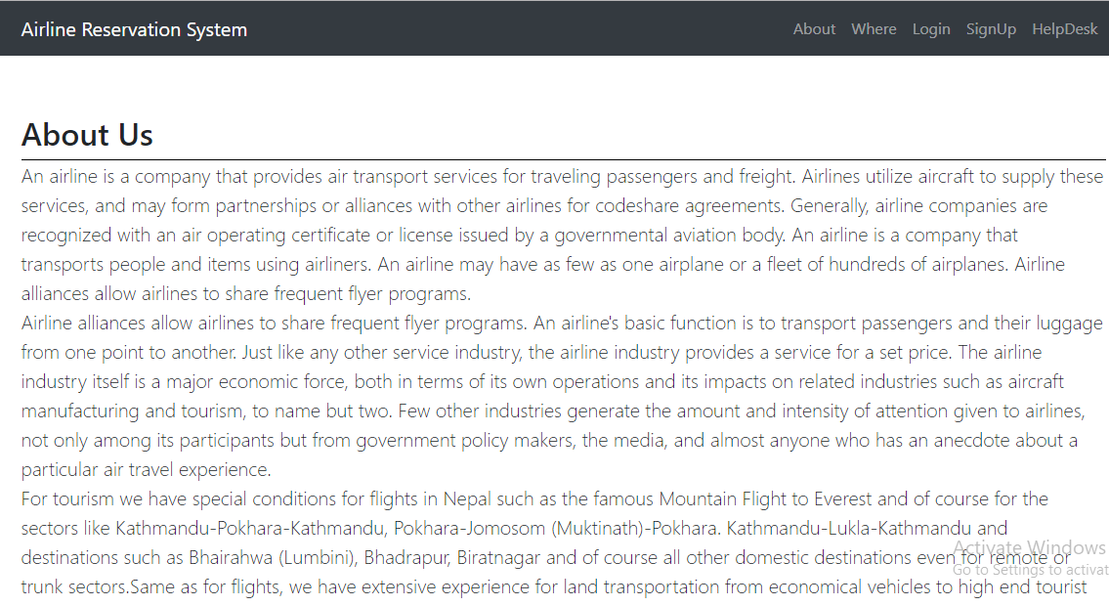

**Figure 74: Website of About Us**

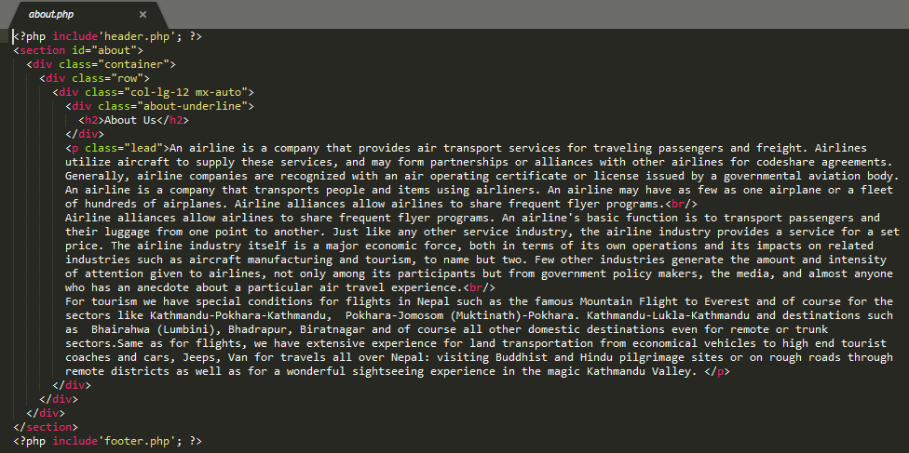

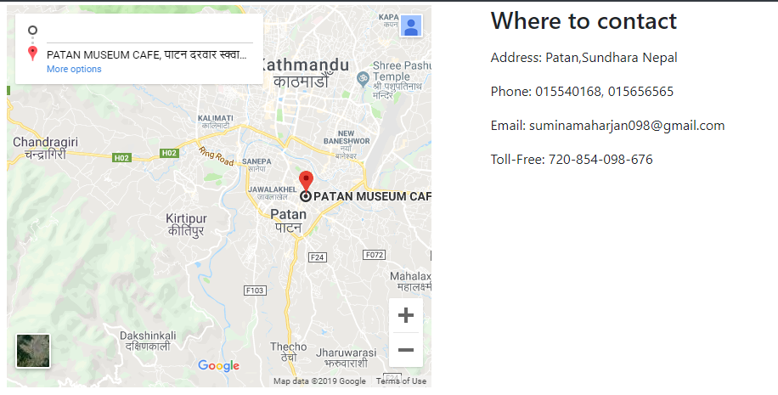

**Figure 75: Website of Where**

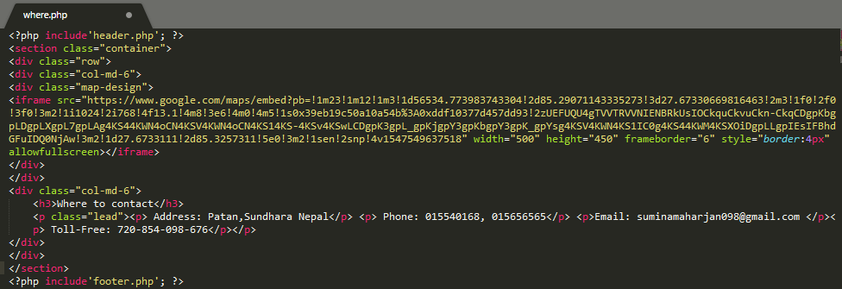

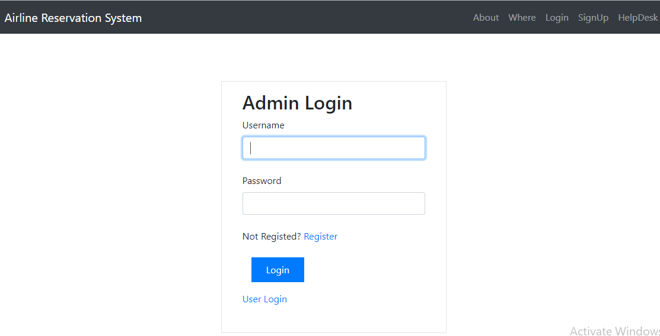

**Figure 76: Website of Admin Login**

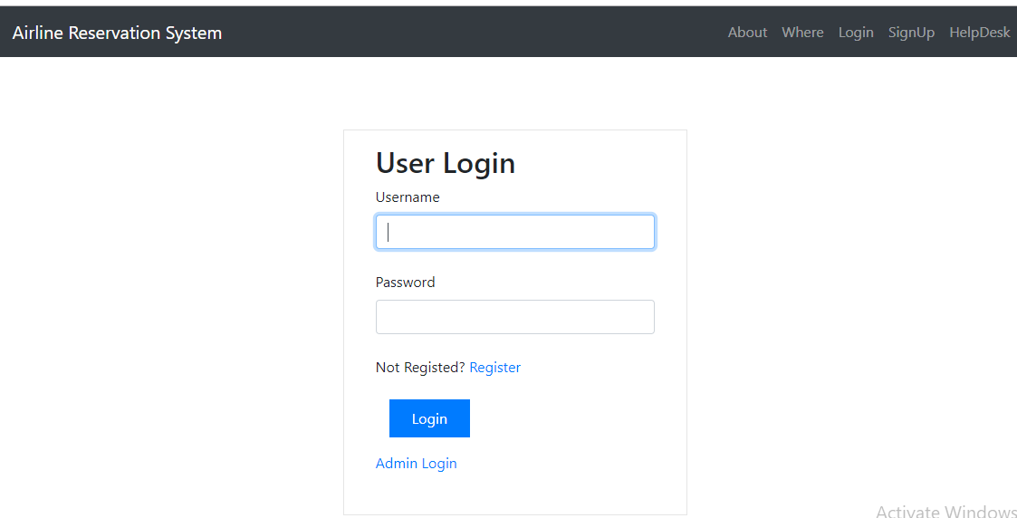

**Figure 77: Website of User Login**

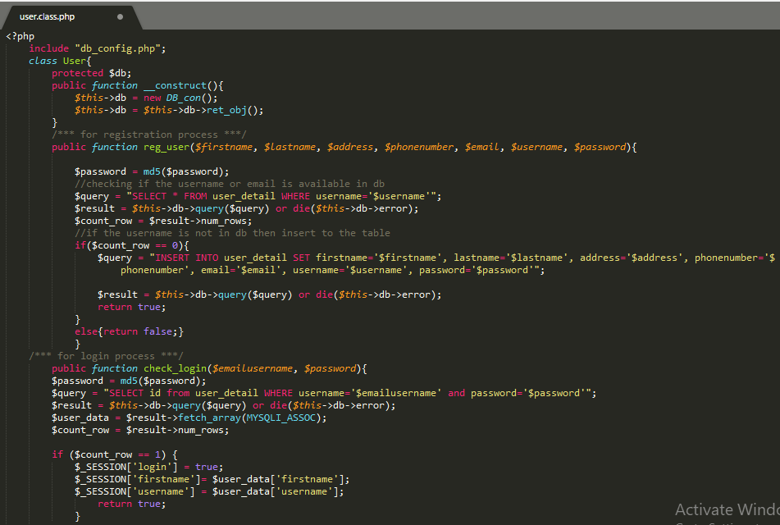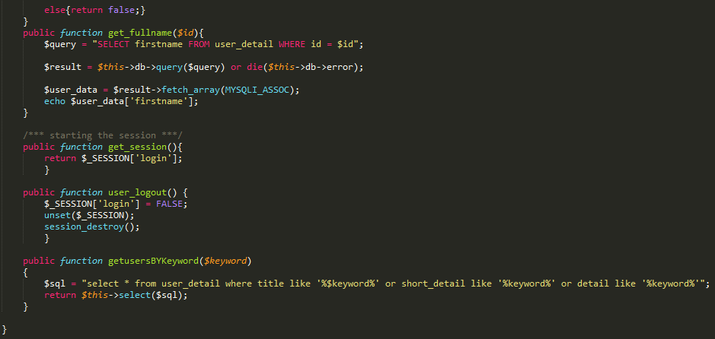

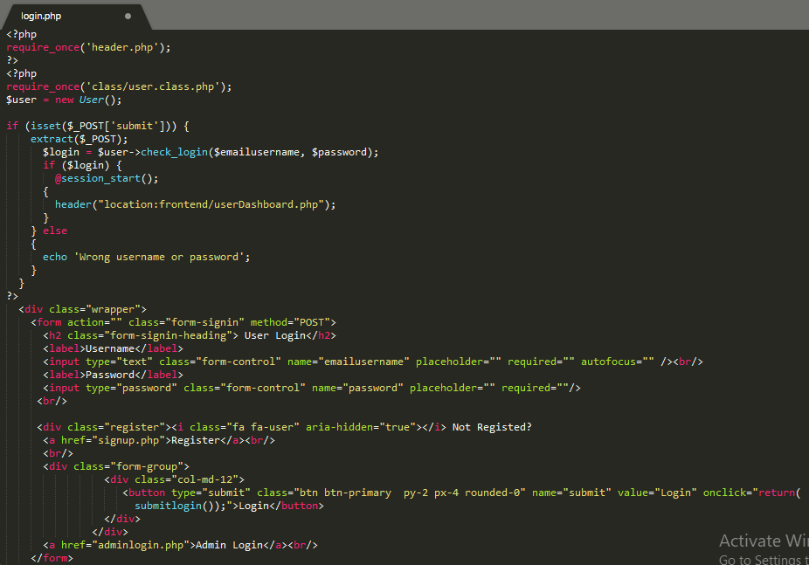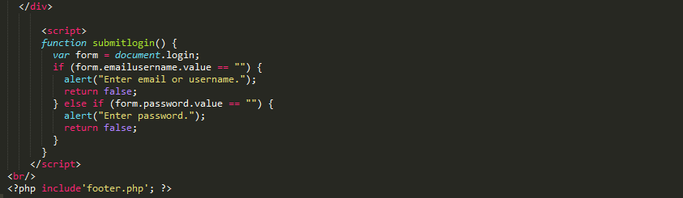

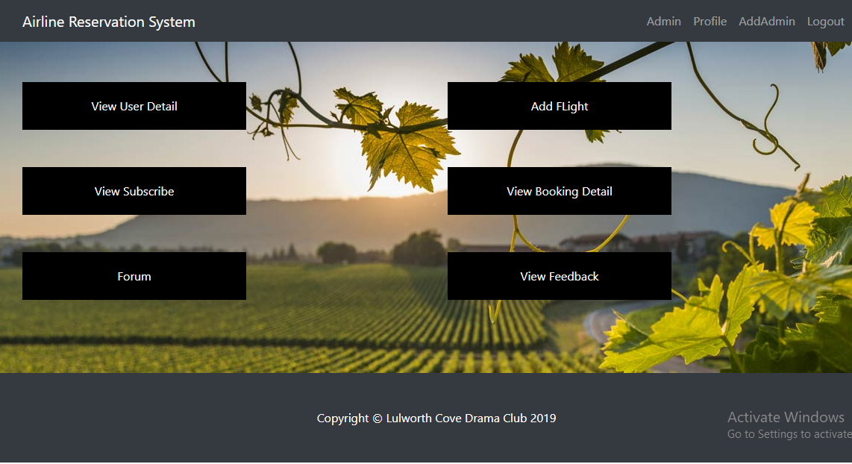

**Figure 78: Website of Admin dashboard**

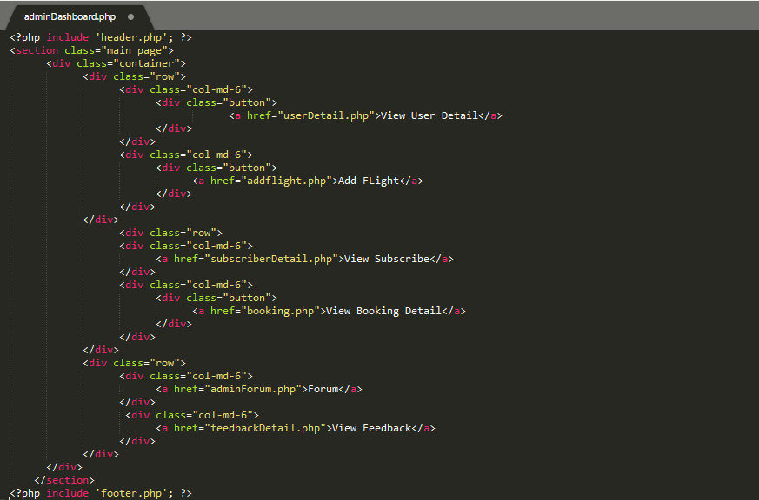

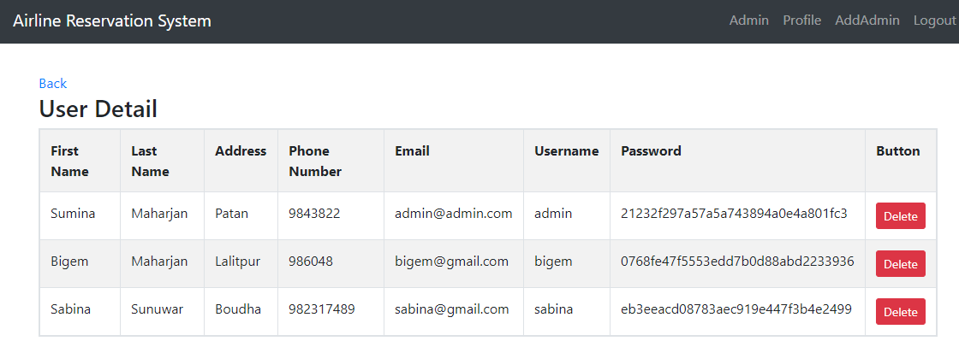

**Figure 79: Website of User Detail**

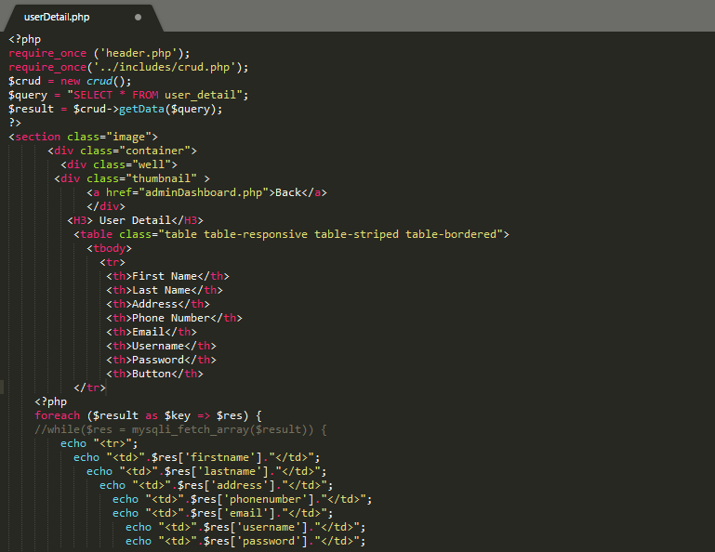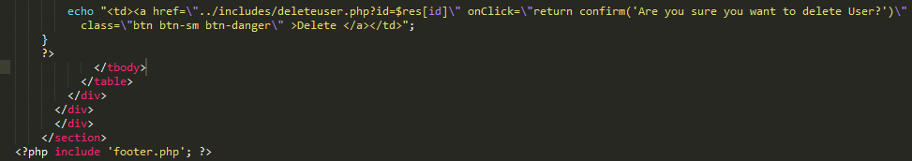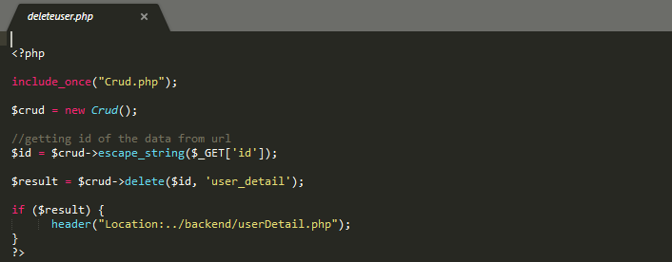

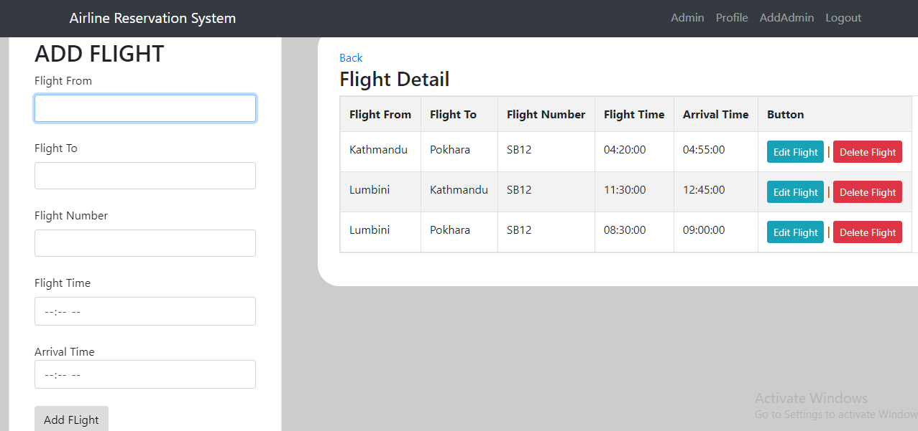

**Figure 80: Website of Add Flight and Flight Detail**

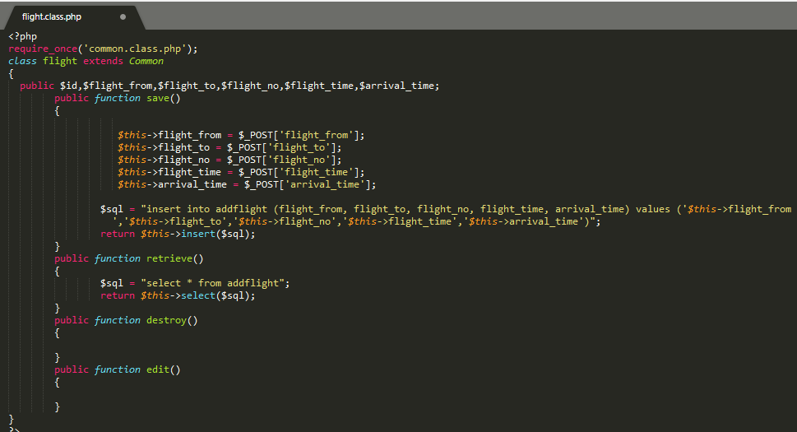

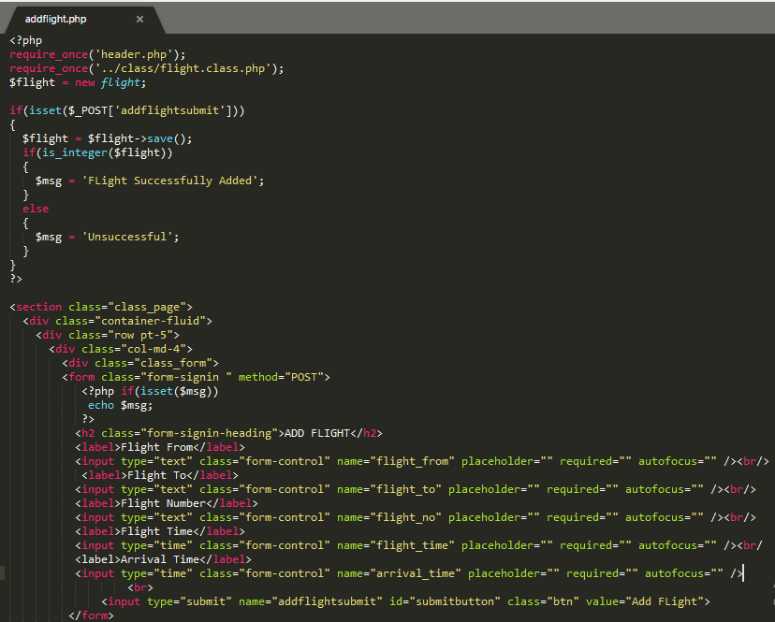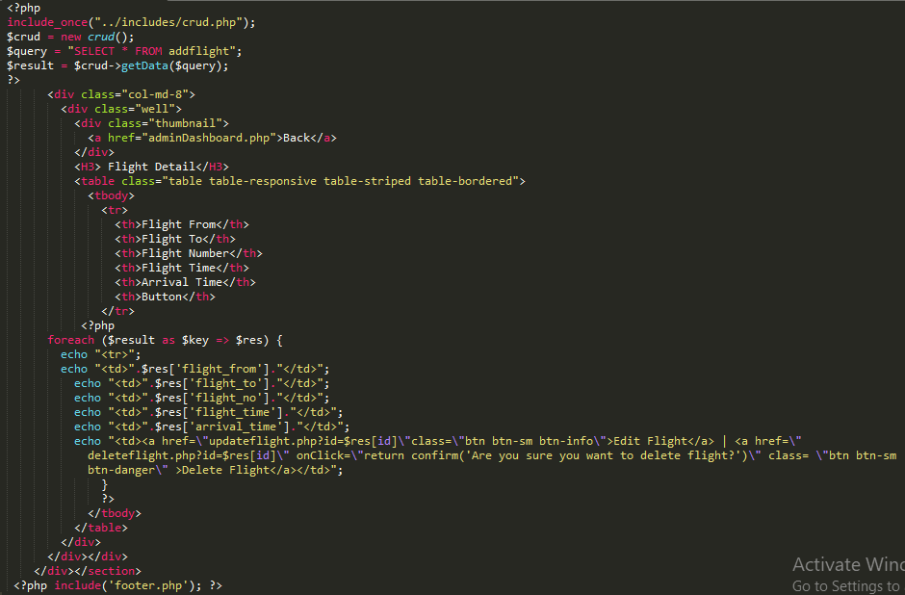

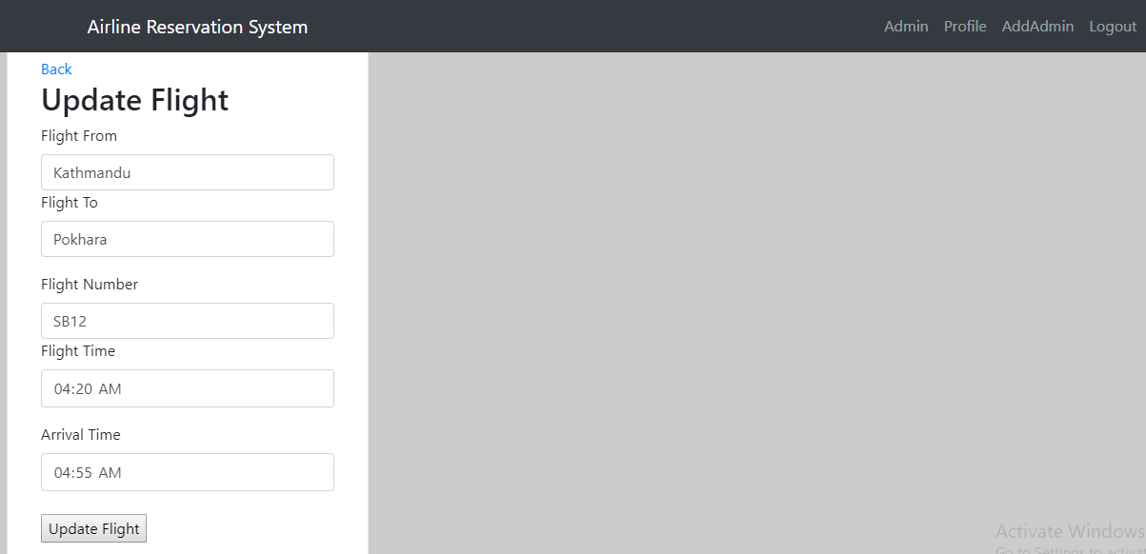

**Figure 81: Website of Update Flight**

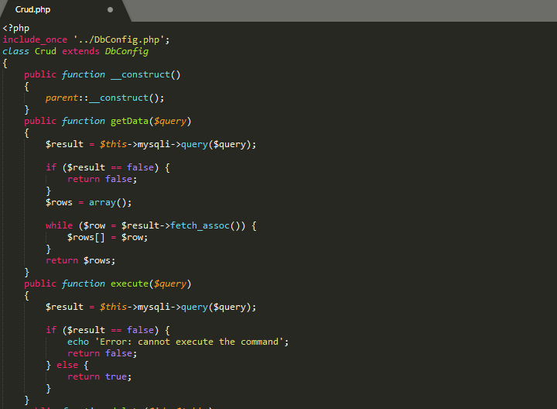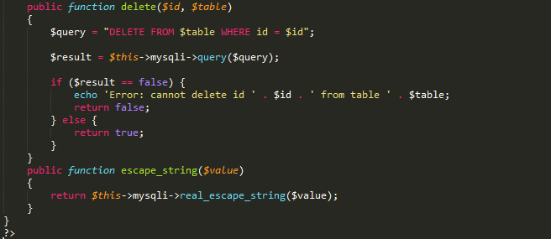

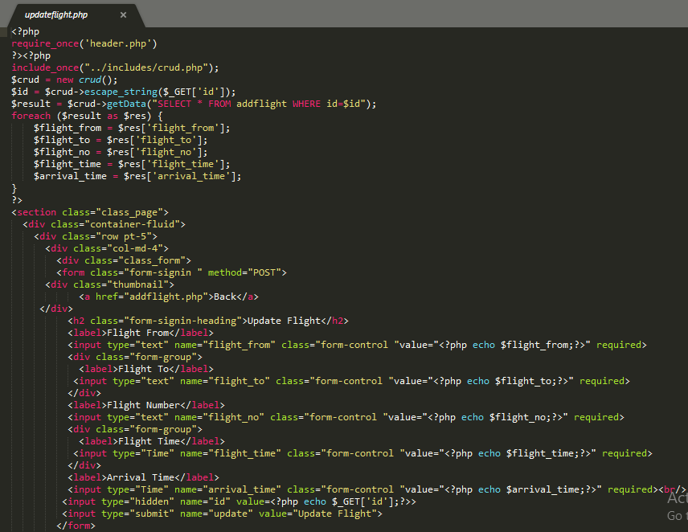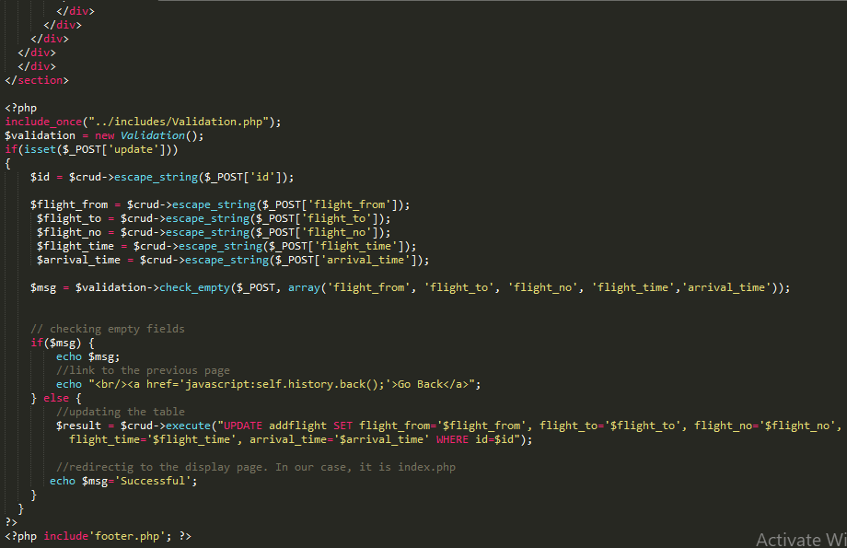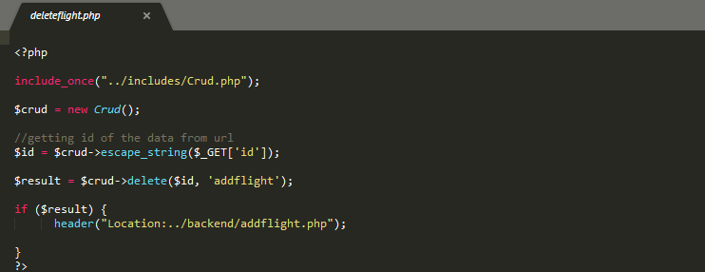

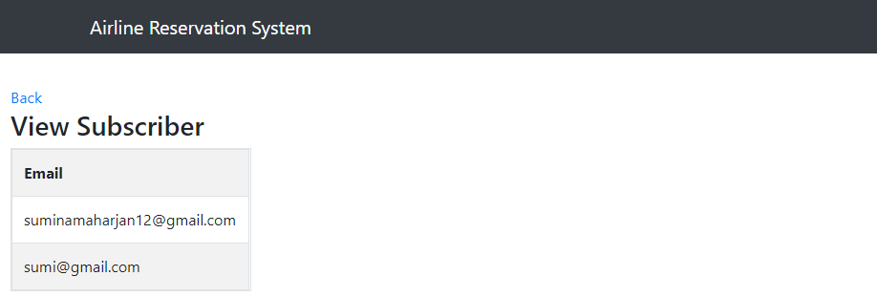

**Figure 82: Website of View Subscriber**

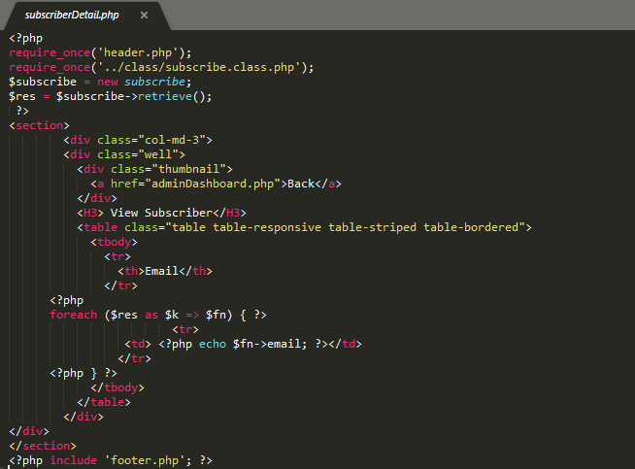

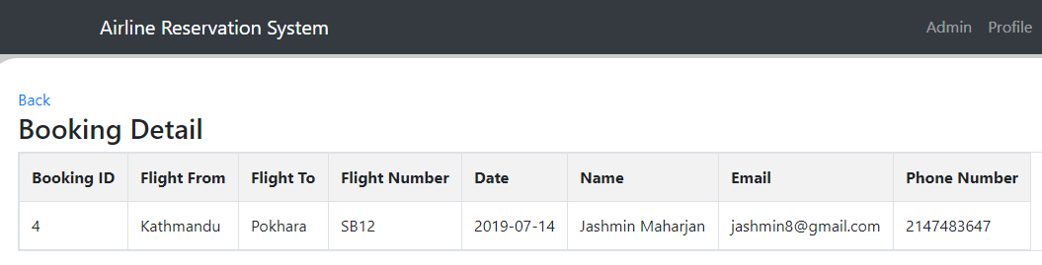

**Figure 83: Website of Booking Detail**

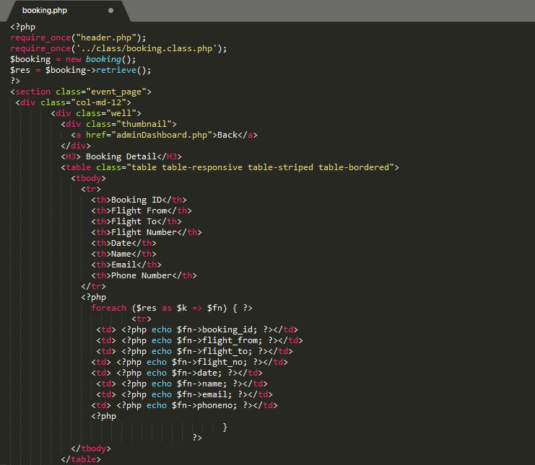

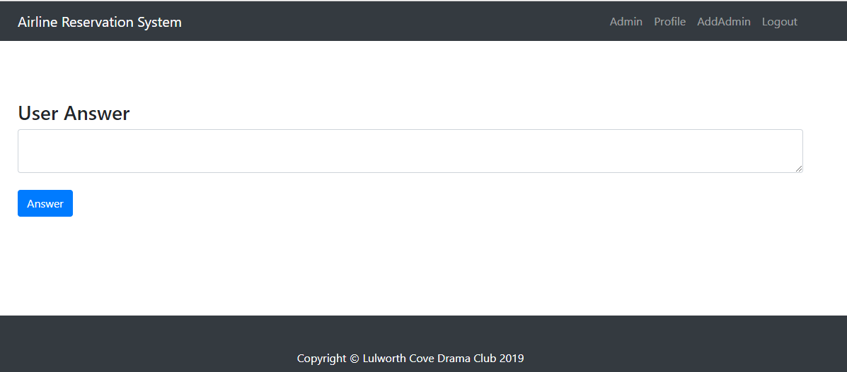

**Figure 84: Website of Admin Forum**

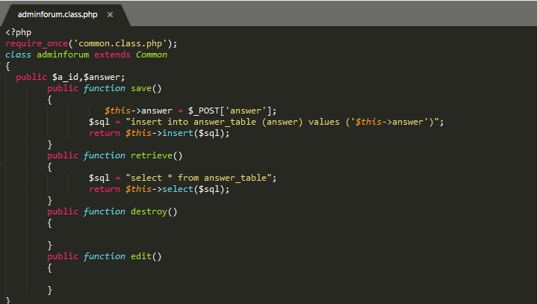

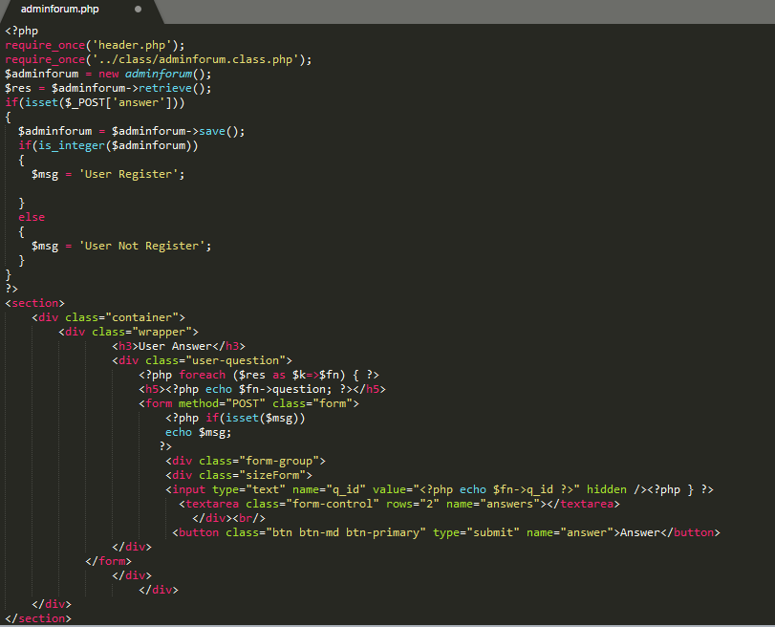

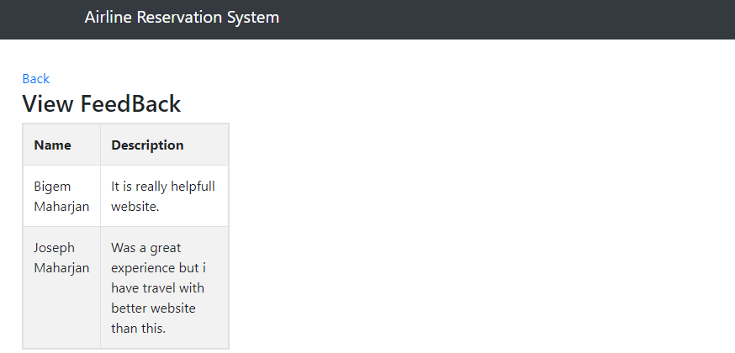

**Figure 85: Website of View Feedback**

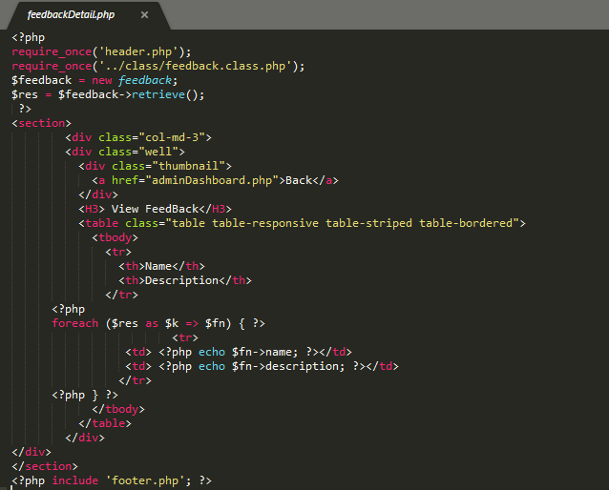

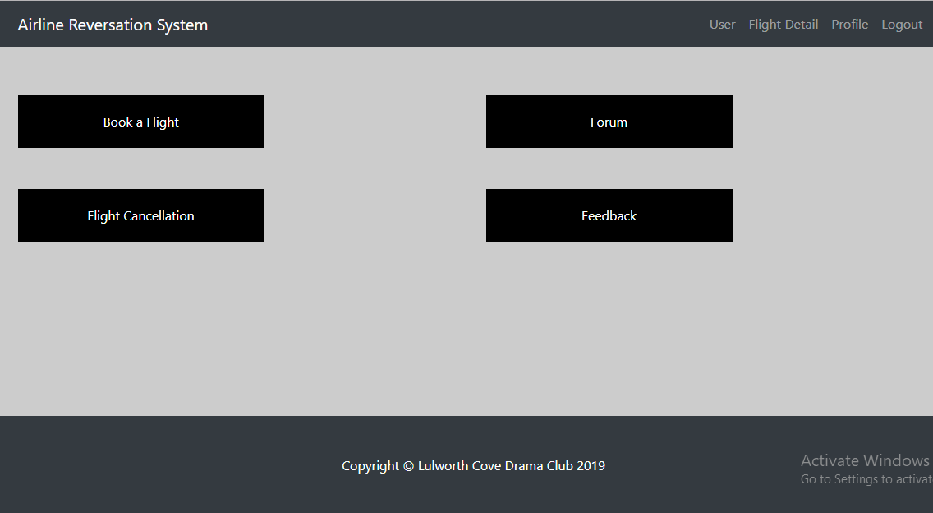

**Figure 86: Website of User Dashboard**

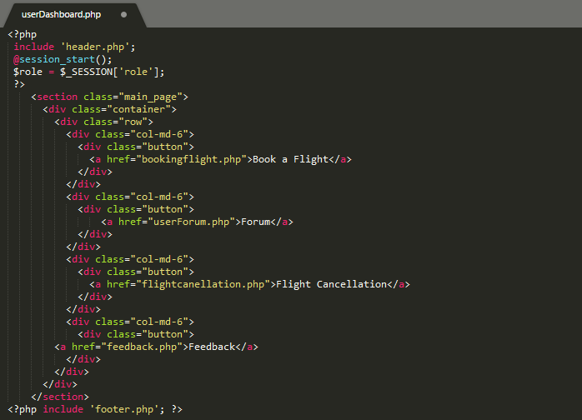

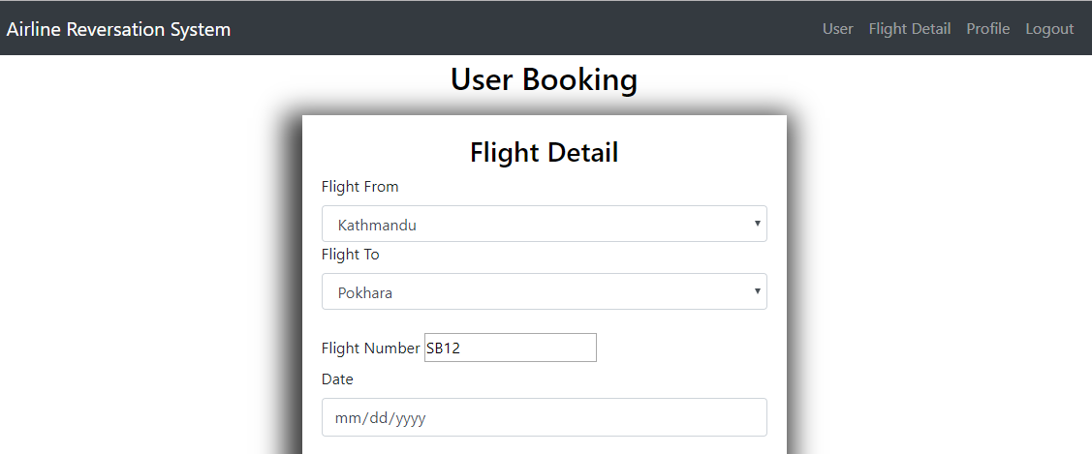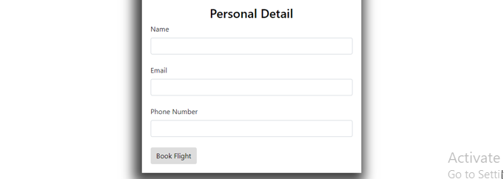

**Figure 87: Website of Booking Form**

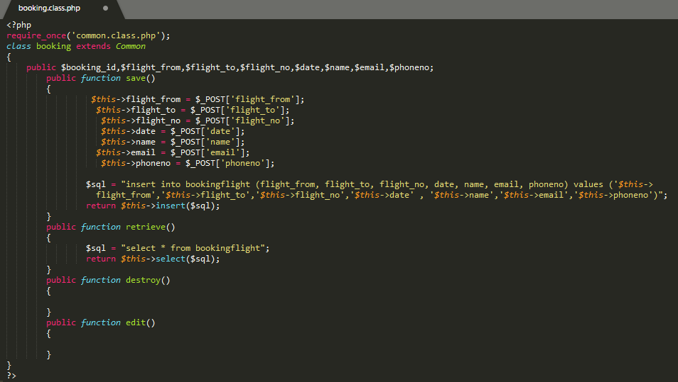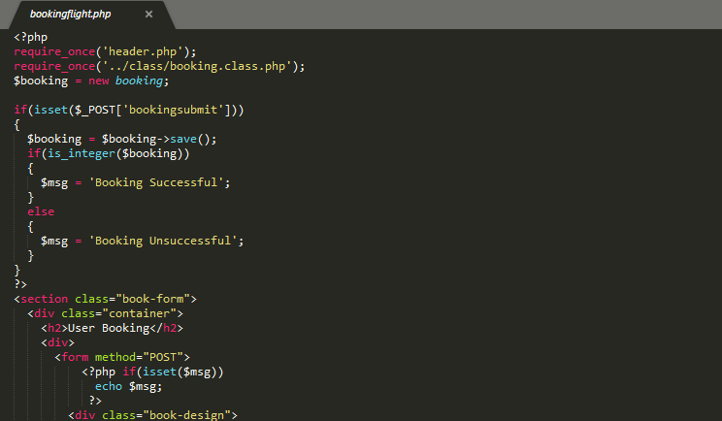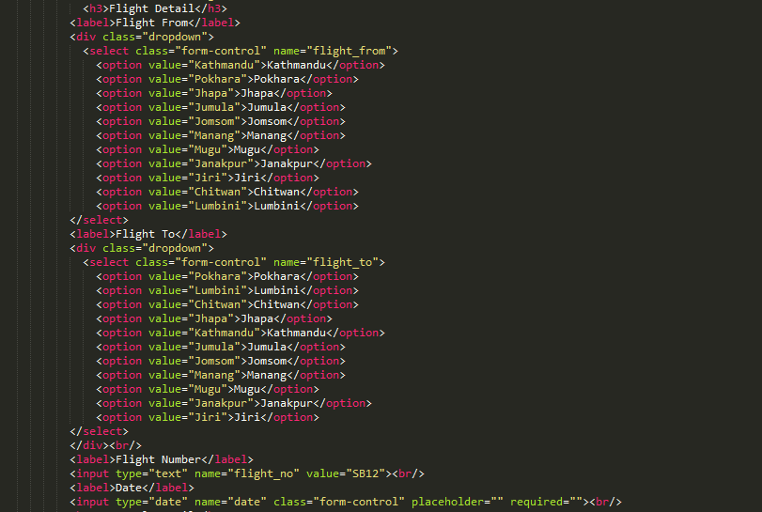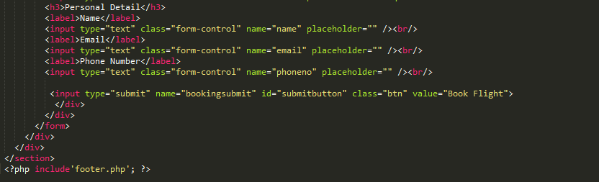

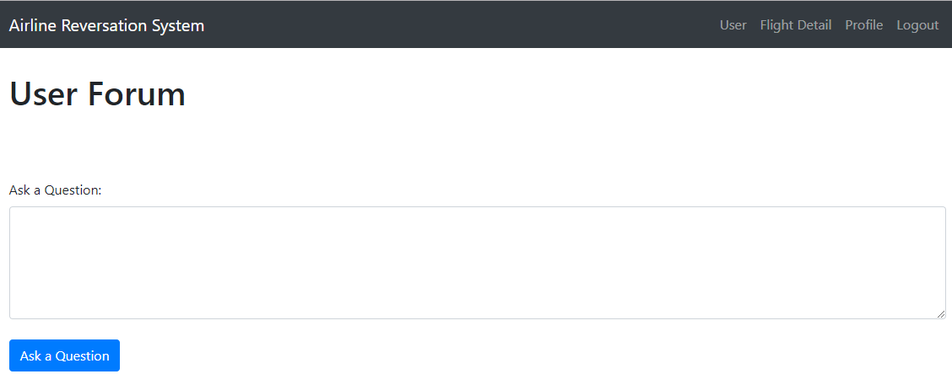

**Figure 88: Website of User Forum**

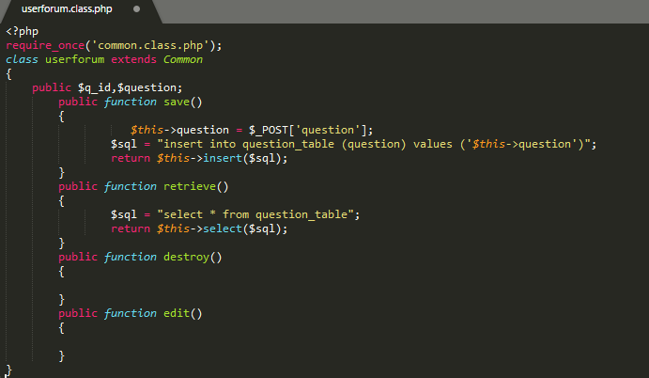

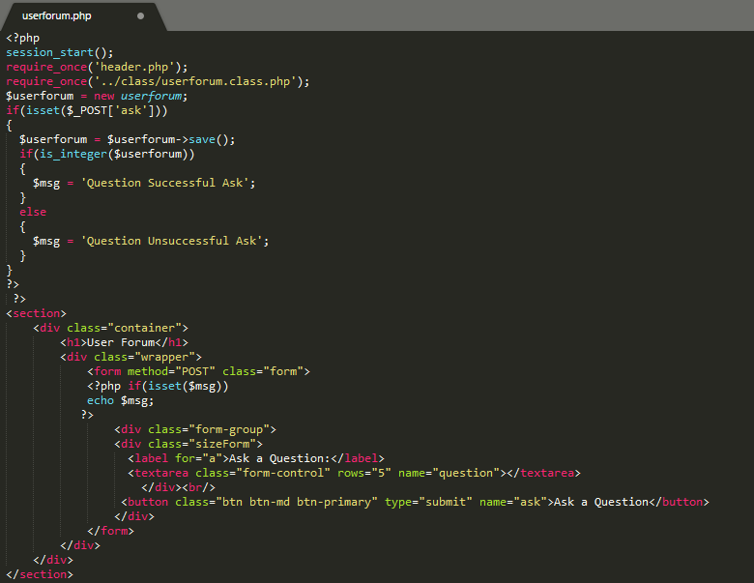

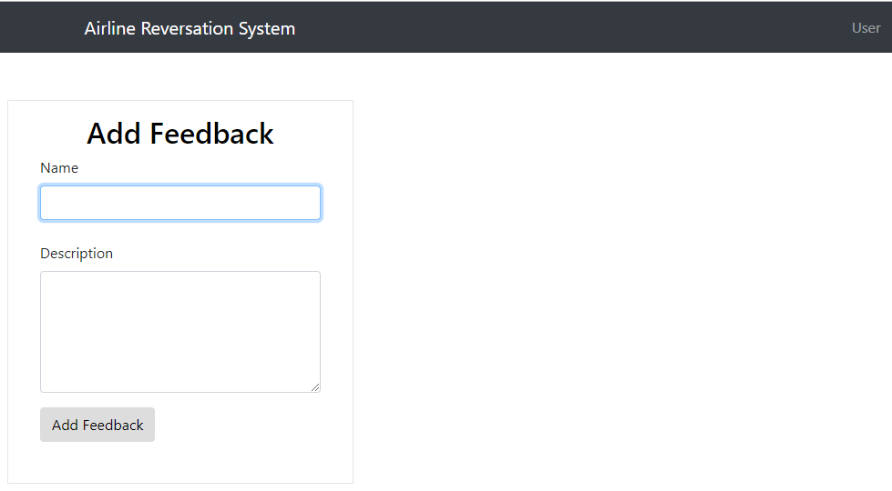

**Figure 89: Website of Add Feedback**

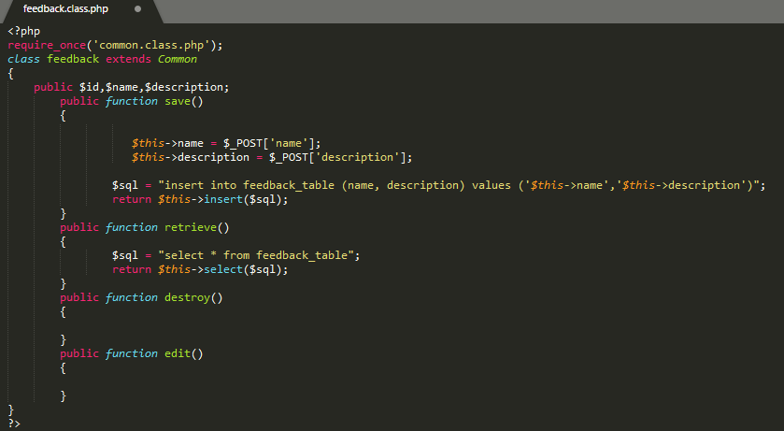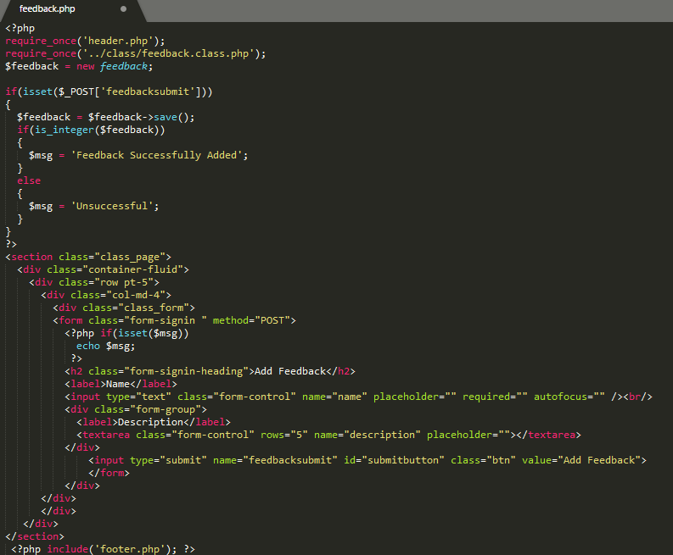

# **Chapter 5: Testing**

## **5.1 Introduction to Testing**

Testing is perform on system to determine the whether the objective are being met or not for checking whether the actual results are as expected results. Testing help in making system error free. Testing can be done manually or by an automated tool where Manual Testing is performed by human that debug codes and errors in software. In other hand, automated testing means using computer programs to execute a system. The testing mainly performed to be ensure that the user wouldn’t face any kind of error.

Testing are of three types listed below:

1. Functional Testing
2. Non-Functional Testing
3. Maintenance

**Types of Testing**

There are various types of testing. Some of them are Unit testing, Integration testing, Acceptance testing, Reliability testing, White box testing, Black box testing, etc. Among these all other types of testing I choose Unit testing and Black box testing for my project.

### **Unit Testing**

Unit testing is a software testing in which individual components/units of a software are tested to validate or determine the software unit works as it is designed. It helps find out the errors while changing of the code. This testing is mainly performed automically.

### **Black Box Testing**

It is a technique of software testing that examines functionality of an application based on the specification. But in this testing the internal structure, design that are being tested is not known to the tester. It supports in deterring the defect earlier during development phase. End User performs this testing by comparing the actual result and expected result.

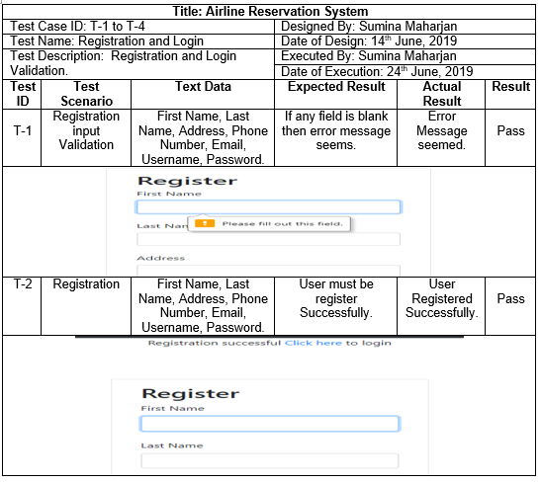

**Figure 90: Blackbox testing of Login and Registration 1**

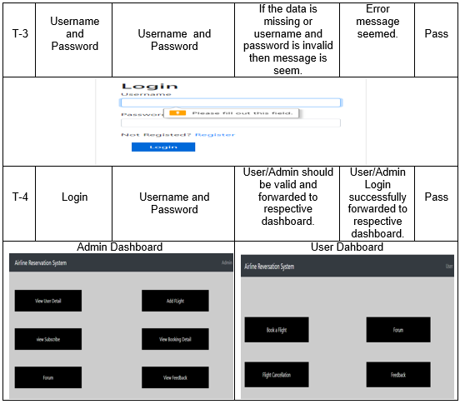

**Figure 91: Blackbox testing of Login and Registration 2**

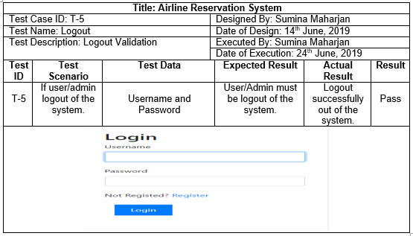

**Figure 92: Blackbox testing of Logout**

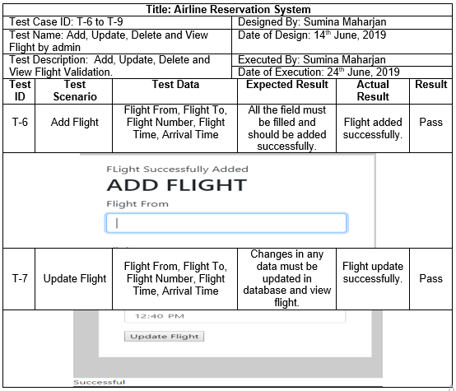

**Figure 93: Blackbox testing of Flight 1**

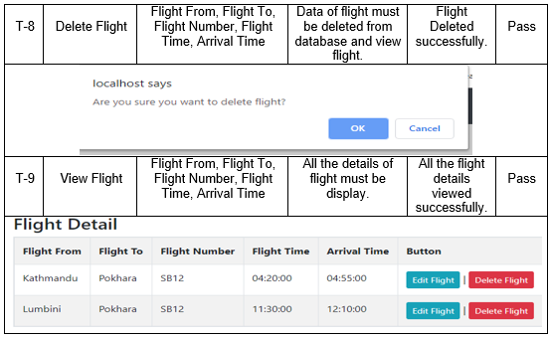

**Figure 94: Blackbox testing of Flight 2**

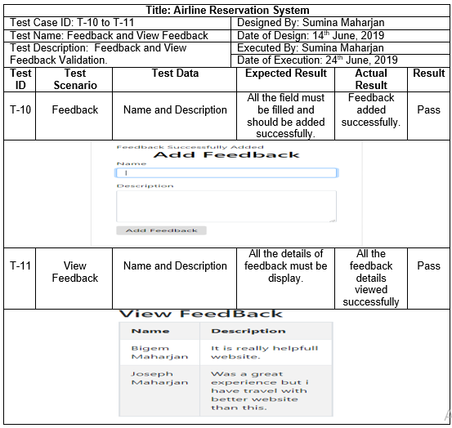

**Figure 95: Blackbox testing of Add and View Feedback**

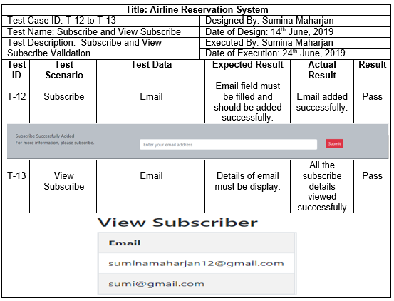

**Figure 96: Blackbox testing of add and view Subscribe**

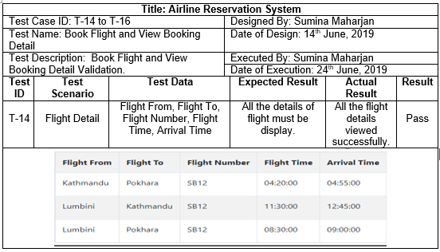

**Figure 97: Blackbox testing of Flight Detail**

# **Chapter 6: Other Project Issues**

After the start of development process the planned activity undertaken to complete application over a decided period of time within the budget that was estimated and gaining the specific aim is called a project. Beyond that, all the situations that occurred and made a negative impact for the project is called as the project issues. The issues like poor quality, design and technical issues are to be maintained through the discussion ending with a better decision.

## **6.1 Project Limitation**

Project limitation refers to the facilities that the application needs but is not available in it due to the restriction in the project management.

**The limitation of my project are:**

* Online transaction method can’t be used by users.
* Confidentiality and Expandability are lacking.
* The users are unable to login through social media.
* This project still hasn’t been focused on International Airline.
* Flight Cancellation can’t be used by users.

## **6.2 Future Work**

Planning for some better features in the present and implementing it in the future ahead which will enhance the system is known as future work. For example: The application that is completed now will have more features in the upcoming years which will express the reliability of the application.

In the current Airline Reservation System I have developed does not include some of the features but will be added in the future. They are:

* Online Payment Method

Online payment method means an electronic payment to pay the money of booking tickets via online just with an internet connection in the device without needing a customer to reach in airline company. The methods to pay online are credit or debit card payments or bank transfers.

* Social Media Addition

Social Media Addition means the user can login quickly into the site using the social media platform like Facebook etc. It means people do no need to visit the airline website page for logging in time to time.

* Forgot Password

Forgot password is an icon in the front page of the login page to change the password if in case a user do not know or forget their account password. But in my project the facility of forgot password is not available and will soon be added in the future.

## **6.3 Project Issues**

Some of the Project issues that I faced during the development process of my project are listed below:

1. I had a problem in fetching and adding value from the database. It was because my Xampp was of old version and were not running successfully so I installed the latest version of Xampp.
2. I had a problem in CSS. The CSS that I changed was not being effected in the web page in Google Chrome. I solved it by uninstalling the Google Chrome and then downloading the update version.

## **6.4 Risk Management**

Risk Management can be defined as identifying and managing the threat. It helps in reducing problems that might affect the project. Risk that occur frequently and makes large amount of loss are handle first and threat with chance of less occurrence and loss are deal in descending order.

Risk can come from different source likewise natural disaster, fail of project and many more. Some risk can be avoided and some cannot be avoided. Natural disaster is unavoidable risk so backup must be kept to face these risk. Analyzing threats and preventive measures must be taken to reduce the risk.

To evaluate the effect of each risk are:

**Impact = Likelihood * Consequence**

Three options of likelihood are:

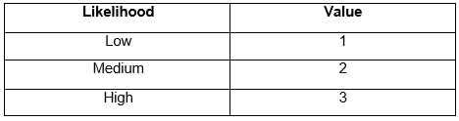

**Figure 98: Likelihood**

There are five options of consequences are:

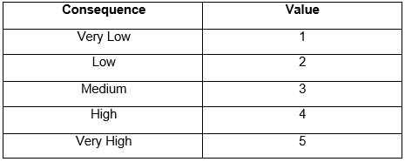

**Figure 99: Consequence**

The following table is of Risk Management:

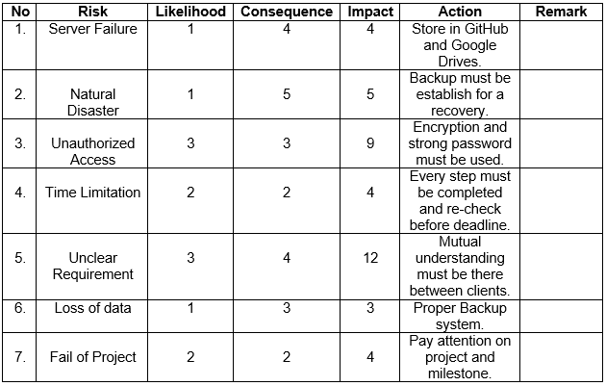

**Figure 100: Risk Management**

## **6.5 Configuration Management**

All project are saved in two locations. One is in the local device in which all the files are created and next one is in GitHub (<https://github.com/maharjansumina/Computing-Project>) which is under the title – Computing-Project. These two locations are in sync using the Git Bash.

Configuration Management is the body of collection of tools, activities, methods and projects. Member of project can use configuration management for managing items in the time of project life cycle. The project composition, project documentation and other supporting project is addressed. It helps to ensure that the documents are not duplicated and it prevents the mistakes.

In the given image below are the folders that manages the project in a local device.

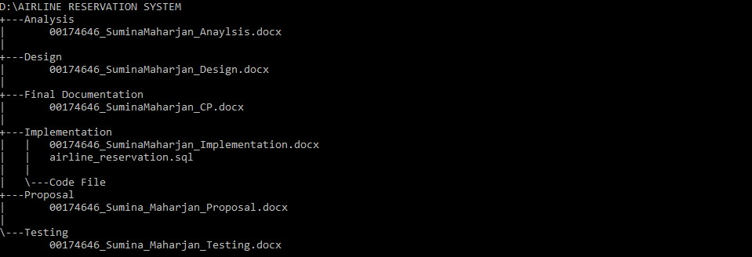

**Figure 101: Project Directory backup inside your Device**

And if in case any document is lost, corrupted or the hardware is failed the projects data are kept backup in an external device.

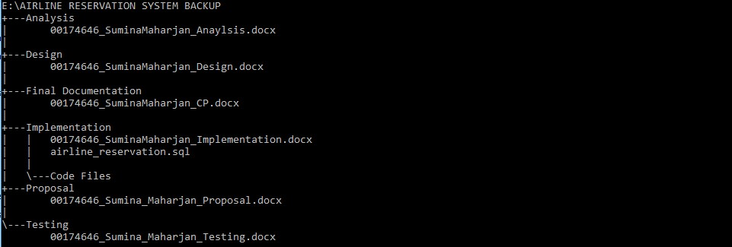

**Figure 102: Project Directory backup inside external Device**

## **6.6 User Manual**

User manual or a User guide refers to the help that is provided to the user on how the system is used in a proper way. It is formatted in a way that every user can understand it. User manual is written in a hardcopy or in an electronic document (PDF or XPS) format. 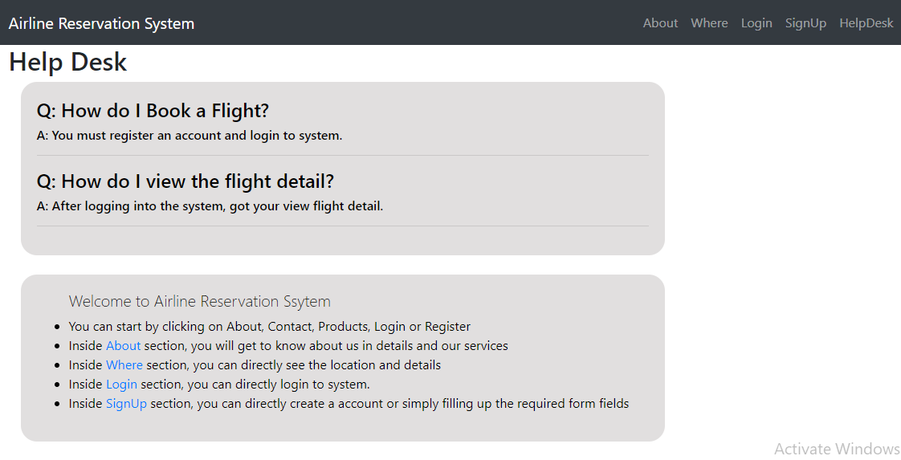

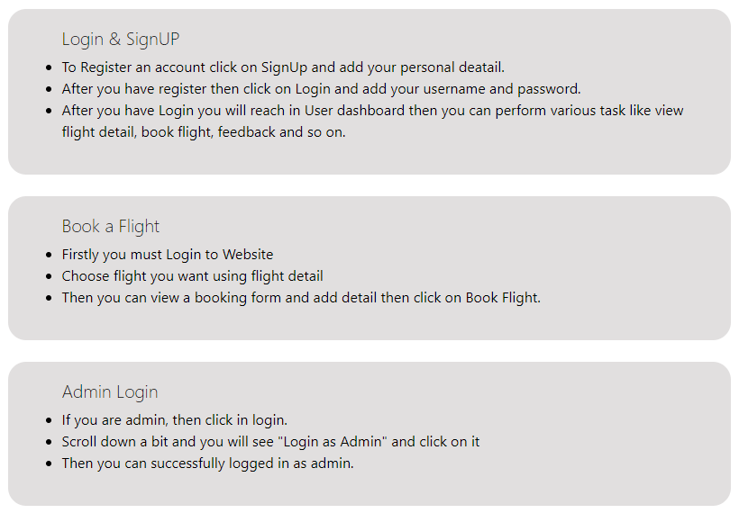

**Figure 103: Website of User Manual 1**

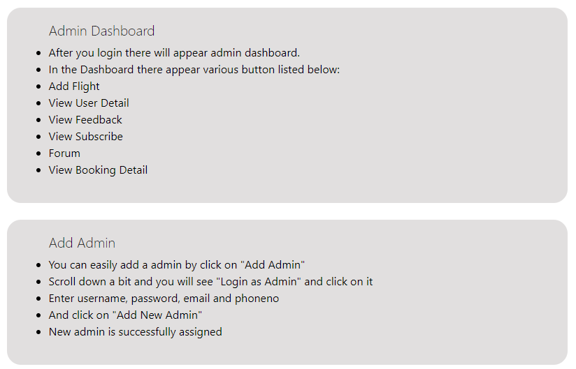

**Figure 104: Website of User Manual**

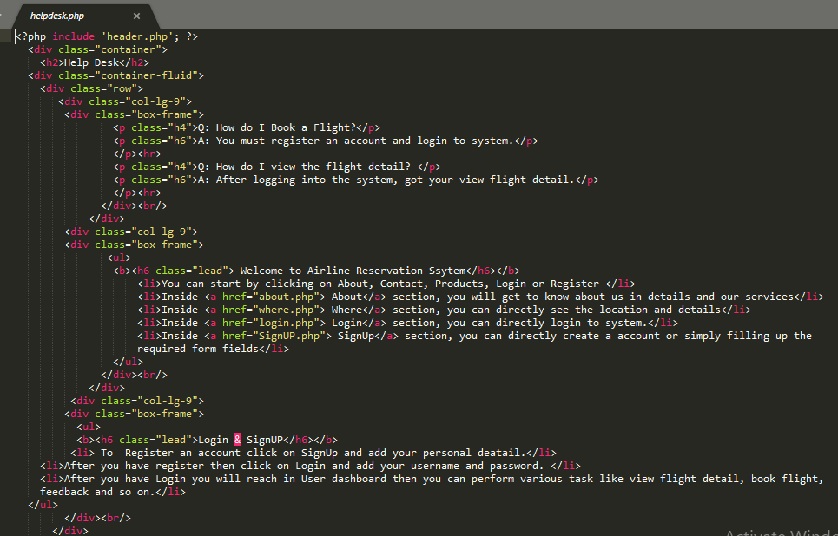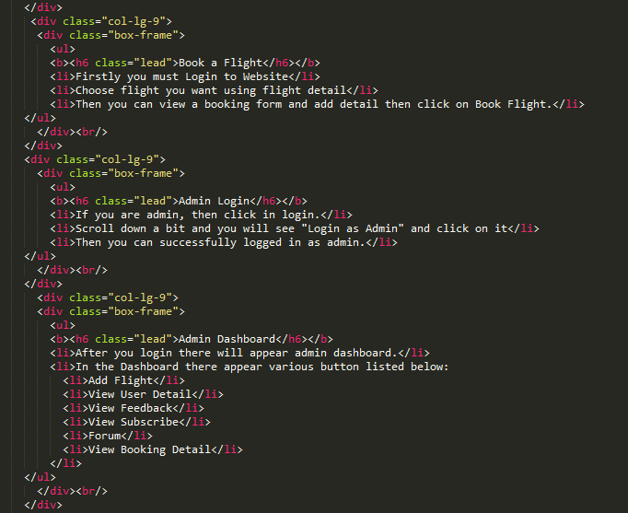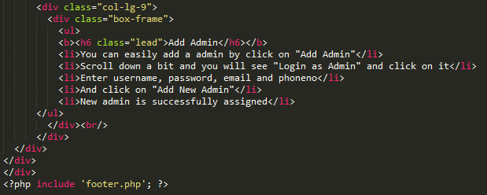

# **Conclusion**

Therefore, Airline Reservation System was completed totally. All the requirements are available as it was initiated. The website I have created is an online booking system for the airlines where the flight details can be known, flight tickets can be booked and once the ticket is booked he or she can know the detail about their reservation. Admin will be able to view the profile of the users and can also change details if required. Admin will keep the details of users in record. The main aim of the project is to provide easy and quick services to the customers.

For my project, I have used object oriented programming PHP, CSS etc. For the database service I have used Xampp. I have used the waterfall methodology, MVC pattern, and client server architecture for achieving goals in my project. The diagrams such as Use case diagram and initial diagram were designed and the various structural diagram were defined that are class diagram, dataflow diagram, activity diagram, sequence diagram, and for the design of database the data dictionary and ER diagram were defined. Black box testing and Unit testing are performed to test the application. Finally, I have also listed all the issues I faced and the work that will be applied in the future to enhance the application and maintain its reliability.

At last, the application was finally completed as per the requirements then implemented into the real time work and delivered successfully to all the customers.

# **References**

* https://www.brighthubpm.com/methods-strategies/106338-soft-systems-methodology-an-overview/ [Accessed 7 May. 2019].
* https://www.toolshero.com/project-management/moscow-method/ [Accessed 5 May. 2019].
* https://www.tutorialcup.com/dbms/data-dictionary-functions.htm [Accessed 27 May. 2019].
* https://insights.diligent.com/entity-relationship-diagramming/what-is-entity-relationship-diagramming-and-why-is-it-important/\ [Accessed 27 May. 2019].
* https://www.geeksforgeeks.org/unified-modeling-language-uml-sequence-diagrams/ [Accessed 30 May. 2019].
* https://www.smartdraw.com/activity-diagram/ [Accessed 30 May. 2019].
* https://www.visual-paradigm.com/tutorials/data-flow-diagram-dfd.jsp [Accessed 3 June. 2019].
* https://www.jcmetalworks.co.uk/knowhow/the-importance-of-prototyping/ [Accessed 3 June. 2019].